
Group Assignment
Module Name: Switching and Routing Essentials
Module Code: CT133-3-2-SRE
Group: BK33
Intake Code: APU2F2511CS(CYB)
Lecturer Name: Joshua Samual
Hand-Out Date: 1 December 2025
Hand-In Date: 27 February 2026
Group Members:
No | NAME | Student ID
1. | Kelver Foo Qai Wen | TP075681
2. | Lian Yuan Shen | TP075827
3. | Heng Li Yang | TP070036
4. | Chong Lih Sin | TP068438
5. | Justin Chew Chun Yuen | TP076179
6. | Chew Wen Kang | TP069443

1.0 Table of Contents
2.0 Introduction 4
3.0 Network Layout 5
4.0 IPv4 and IPv6 Addressing Table 6
4.1 WAN Network 6
4.2.1 KL Internal Links 6
4.2.2 KL LAN 6
4.3.1 Penang Internal Links 7
4.3.2 Penang LAN 7
4.4.1 JB Internal Links 7
4.4.2 JB LAN 8
4.5.1 Malacca Internal Links 8
4.5.2 Malacca LAN 9
5.0 WAN and LAN Configuration 9
5.1 WAN 9
5.1.2 Explanation 9
5.1.2 Configuration 10
5.2 LAN 12
5.2.1 Internal Links 12
5.2.2 Router-on-a-Stick (ROAS) 14
5.3 OSPF 17
5.3.1 Explanation 17
5.3.2 Configuration 18
6.0 WLAN Architecture 22
6.1 Penang Branch 22
6.2 JB Branch 26
7.0 EtherChannel 30
8.0 HSRP Implementation 32
9.0 Server Services 36
9.1 DNS Server 37
9.1.1 DNS Testing 39
9.2 FTP Server 40
9.2.1 FTP Testing 42
9.3 Web Server 47
9.3.1 Web Testing 49
9.4 DHCP Server 50
9.4.1 DHCP Testing 54
9.5 DHCPv6 Server 55
9.5.1 DHCPv6 Testing 58
10.0 Tracert/Ping Commands 59
11.0 Security Mechanisms 62
11.1 Basic Router Configurations 62
11.1.1 Banner and Password Encryption 62
11.1.2 Console Line Security 63
11.1.3 Privileged Access 65
11.1.4 Logging and Timestamps 65
11.1.5 SSH Configuration 66
11.2 Switches 68
12.1 Security Mechanisms Improvement 75
12.2 Recommendations 83
13.0 IOT 84
14.0 Conclusion 92
15.0 References 93
16.0 Workload Matrix 95

2.0 Introduction
An organization requires a properly developed network infrastructure that will guarantee effective communication, scalability, and security. The importance of structured network segmentation, dynamic routing, wireless control, and redundancy mechanisms gets more significant as businesses have to be developed in more locations. Thus, topology should be chosen properly, and proper networking technologies should be used to make it reliable and performant.
This project deals with the design and implementation of a multi-site enterprise network of Suzlon that has operations in Kuala Lumpur (HQ), Malacca, Johor Bahru (JB), and Penang. The proposed network is hierarchical star topology, using a three-tier architecture comprising core, distribution, and access layers. The reason why this topology is chosen is because it has high scalability, a centralized management facility, better performance, and provides redundancy and security deployments.
VLAN design segmentation to isolate the departmental traffic, inter-VLAN routing to facilitate communication across departments, and OSPF dynamic routing with default static routes are used to make sure that there is connectivity across the sites. DHCPv4 is adopted to automate the distribution of IP addresses in a range of LANs. The Penang and JB have a Wireless LAN Controller (WLC) architecture, which is secured with WPA2 authentication, whereas KL and Malacca are wholly wired networks.
Variable Length Subnet Masking (VLSM) is implemented to effectively allocate the IP addresses, as in an internal network, the private IP addresses are used whereas in a WAN connection and the Server Farm network, the public IP addresses are utilized when needed. The use of HSRP, Etherchannel, and Layer 2 mitigation measures against attacks are also provided to improve redundancy and security. The complete topology is designed and tested with Cisco Packet Tracer so that the complete end-to-end connectivity is achieved.

3.0 Network Layout
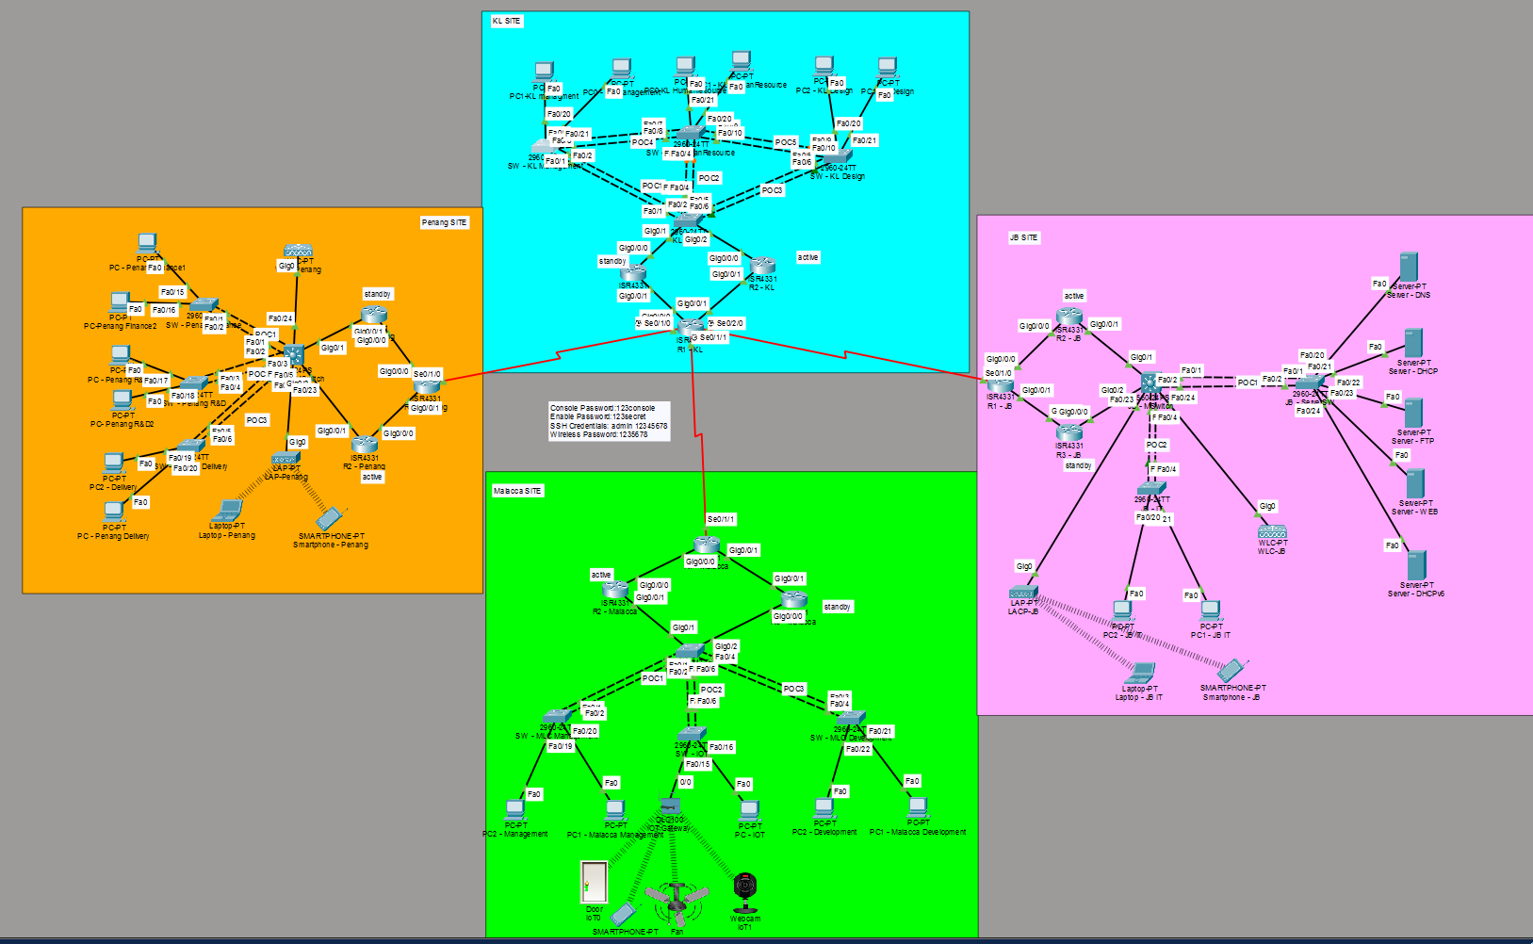
The network topology used in this project is a hybrid hierarchical enterprise network design. It follows a hub-and-spoke WAN architecture where the KL site functions as the core hub connecting to branch sites in Penang, Melaka, and JB. Within each site, a hierarchical star topology is implemented using core, distribution, and access layers to ensure scalability, redundancy, and efficient traffic management.

4.0 IPv4 and IPv6 Addressing Table

4.1 WAN Network
Link | Router | Interface | IPv4 Address | Subnet Mask | IPv6 Address
KL to Penang | R1-KL | Serial0/1/0 | 203.0.3.1/30 | 255.255.255.252 | 2001:203:3::1/127
Penang to KL | R1-Penang | Serial0/1/0 | 203.0.3.2/30 | 255.255.255.252 | 2001:203:3::2/127
KL to JB | R1-KL | Serial0/2/0 | 203.0.4.1/30 | 255.255.255.252 | 2001:203:4::1/127
JB to KL | R1-JB | Serial0/1/0 | 203.0.4.2/30 | 255.255.255.252 | 2001:203:4::2/127
KL to Malacca | R1-KL | Serial0/1/1 | 203.0.5.1/30 | 255.255.255.252 | 2001:203:5::1/127
Malacca to KL | R1-Malacca | Serial0/1/1 | 203.0.5.2/30 | 255.255.255.252 | 2001:203:5::2/127

4.2.1 KL Internal Links
Link | Router | Interface | IPv4 Address | Subnet Mask | IPv6 Address
R1 to R2 | R1-KL | Gig0/0/1 | 10.255.2.1/30 | 255.255.255.252 | fd00:db8:2::1/127
R2 to R1 | R2-KL | Gig0/0/1 | 10.255.2.2/30 | 255.255.255.252 | fd00:db8:2::2/127
R1 to R3 | R1-KL | Gig0/0/0 | 10.255.12.1/30 | 255.255.255.252 | fd00:db8:12::1/127
R3 to R1 | R3-KL | Gig0/0/1 | 10.255.12.2/30 | 255.255.255.252 | fd00:db8:12::2/127

4.2.2 KL LAN
VLAN | Department | IPv4 Subnet | IPv4 Gateway | IPv4 DHCP Pool | IPv6 Subnet | IPv6 Gateway | IPv6 DHCP Pool | Hosts
10 | KL_Management | 10.1.10.0/26 | 10.1.10.1 | 10.1.10.2–10.1.10.62 | fd00:1:10::/64 | fd00:1:10::1 | fd00:1:10::2–fd00:1:10::62 | 50
20 | KL_HumanResource | 10.1.10.64/27 | 10.1.10.65 | 10.1.10.66–10.1.10.94 | fd00:1:20::/64 | fd00:1:20::1 | fd00:1:20::2–fd00:1:20::30 | 30
30 | KL_Design | 10.1.10.96/27 | 10.1.10.97 | 10.1.10.98–10.1.10.126 | fd00:1:30::/64 | fd00:1:30::1 | fd00:1:30::2–fd00:1:30::40 | 30

4.3.1 Penang Internal Links
Link | Router | Interface | IPv4 Address | Subnet Mask | IPv6 Address
R1 to R2 | R1-Penang | Gig0/0/1 | 10.255.6.1/30 | 255.255.255.252 | fd00:db8:6::1/127
R2 to R1 | R2-Penang | Gig0/0/0 | 10.255.6.2/30 | 255.255.255.252 | fd00:db8:6::2/127
R1 to R3 | R1-Penang | Gig0/0/0 | 10.255.7.1/30 | 255.255.255.252 | fd00:db8:7::1/127
R3 to R1 | R3-Penang | Gig0/0/0 | 10.255.7.2/30 | 255.255.255.252 | fd00:db8:7::2/127

4.3.2 Penang LAN
VLAN | Department | IPv4 Subnet | IPv4 Gateway | IPv4 DHCP Pool | IPv6 Subnet | IPv6 Gateway | IPv6 DHCP Pool | Hosts
40 | Finance | 10.2.10.0/26 | 10.2.10.1 | 10.2.10.2–10.2.10.62 | fd00:2:40::/64 | fd00:2:40::1 | fd00:2:40::2–fd00:2:40::50 | 50
50 | R&D | 10.2.10.64/26 | 10.2.10.65 | 10.2.10.66–10.2.10.126 | fd00:2:50::/64 | fd00:2:50::1 | fd00:2:50::2–fd00:2:50::50 | 50
60 | Delivery | 10.2.10.128/26 | 10.2.10.129 | 10.2.10.130–10.2.10.190 | fd00:2:60::/64 | fd00:2:60::1 | fd00:2:60::2–fd00:2:60::40 | 40

4.4.1 JB Internal Links
Link | Router | Interface | IPv4 Address | Subnet Mask | IPv6 Address
R1 to R2 | R1-JB | Gig0/0/0 | 10.255.8.1/30 | 255.255.255.252 | fd00:db8:8::1/127
R2 to R1 | R2-JB | Gig0/0/0 | 10.255.8.2/30 | 255.255.255.252 | fd00:db8:8::2/127
R1 to R3 | R1-JB | Gig0/0/1 | 10.255.9.1/30 | 255.255.255.252 | fd00:db8:9::1/127
R3 to R1 | R3-JB | Gig0/0/1 | 10.255.9.2/30 | 255.255.255.252 | fd00:db8:9::2/127

4.4.2 JB LAN
VLAN | Depart  ment | IPv4 Subnet | IPv4 Gateway | IPv4 DHCP Pool | IPv6 Subnet | IPv6 Gateway | IPv6 DHCP Pool | Hosts
100 | IT | 192.168.10.0/26 | 192.168.10.1 | 192.168.10.2–192.168.10.62 | fd00:4:100  ::/64 | fd00:4:100::/64 | fd00:2:40::2–fd00:2:40::50 | 50
110 | Server  Farm | 203.0.110.0/27 | 203.0.110.1 | 203.0.110.2 – 203.0.110.30 | 2001:203:  abcd:10::/64 | 2001:203:  abcd:10::/64 | fd00:2:50::2–fd00:2:50::50 | 50

4.5.1 Malacca Internal Links
Link | Router | Interface | IPv4 Address | Subnet Mask | IPv6 Address
R1 to R2 | R1-Malacca | Gig0/0/0 | 10.255.10.1/30 | 255.255.255.252 | fd00:db8:10::1/127
R2 to R1 | R2- Malacca | Gig0/0/0 | 10.255.10.2/30 | 255.255.255.252 | fd00:db8:10::2/127
R1 to R3 | R1- Malacca | Gig0/0/1 | 10.255.11.1/30 | 255.255.255.252 | fd00:db8:11::1/127
R3 to R1 | R3- Malacca | Gig0/0/1 | 10.255.11.2/30 | 255.255.255.252 | fd00:db8:11::2/127

4.5.2 Malacca LAN
VLAN | Department | IPv4 Subnet | IPv4 Gateway | IPv4 DHCP Pool | IPv6 Subnet | IPv6 Gateway | IPv6 DHCP Pool | Hosts
70 | Management | 172.16.10.0/26 | 172.16.10.1 | 172.16.10.2–172.16.10.62 | fd00:3:70::/64 | fd00:3:70::1 | fd00:3:70::2–fd00:3:70::50 | 50
80 | Development | 172.16.10.64/26 | 172.16.10.65 | 172.16.10.66–172.16.10.126 | fd00:3:80::/64 | fd00:3:80::1 | fd00:3:80::2–fd00:3:80::40 | 40
90 | IoT | 172.16.10.128/27 | 172.16.10.129 | 172.16.10.130–172.16.10.158 | fd00:3:90::/64 | fd00:3:90::1 | fd00:3:90::2–fd00:3:90::20 | 20

5.0 WAN and LAN Configuration

5.1 WAN

5.1.2 Explanation
The Architecture of the WAN
Physically separating the main headquarters in Kuala Lumpur (KL) from the regional offices in Penang, Johor Bahru (JB), and Malacca is the Wide Area Network (WAN), which acts as the main communication backbone. Efficiency, security, and administrative clarity are given top priority in this carefully planned system, which goes beyond a simple arrangement of cables.
Structural Logic and Topology
The Hub-and-Spoke topology, which is the best option for businesses with a prominent central site, is used by the network such as Suzlon. According to this paradigm, R1-KL serves as the main "Hub," overseeing specific long-distance connections to the "Spoke" routers at every regional site. The centralized implementation of security firewalls and easier monitoring are made possible by this architecture, which streamlines traffic flow by guaranteeing that all inter-branch data flows through a single location.
IPv4 Addressing
The precise usage of the IPv4 address space is one of this WAN's distinguishing features. To guarantee that no IP addresses are wasted, the design makes use of /30 subnets such as “203.0.3.0/30”. According to the formula 2^{(32-30)} - 2 = 2, a /30 mask offers precisely two useable host addresses, one for each end of the connection, making it theoretically optimal for point-to-point links. The /30 option is both technically sound and resource-responsible because using a larger subnet, as a /24, would leave hundreds of addresses unused and insecure.
IPv6 Addressing
The IPv6 implementation prioritizes security and protocol performance, whereas IPv4 concentrates on conservation. All inter-router links in the network use /127 prefixes, as 2001:203:3::1/127. RFC 6164, an industry standard practice that guards against specialized "Ping-Pong" attacks, is followed in this configuration. The routers are shielded from neighbour discovery cache exhaustion by restricting the subnet to just two addresses. This keeps the central hub safe from malicious traffic that targets unused address space on the WAN lines.
Administrative Clarity and Management
Lastly, the network is made to be very readable by humans, which is crucial for quick troubleshooting. The third octet of the IPv4 address and the third hextet of the IPv6 address are always the same since the addressing system has a mirrored logical structure. For instance, in both protocols (203.0.4.x and 2001:203:4::x), the number "4" designates the link to JB, but the number "5" designates Malacca. The "mean time to repair" (MTTR) during network failures is greatly decreased thanks to this methodical mapping, which enables a network engineer to determine the physical link and city connected with each packet just by looking at its IP header.

5.1.2 Configuration
Example of configuration made on R1-KL, the “Hub”:
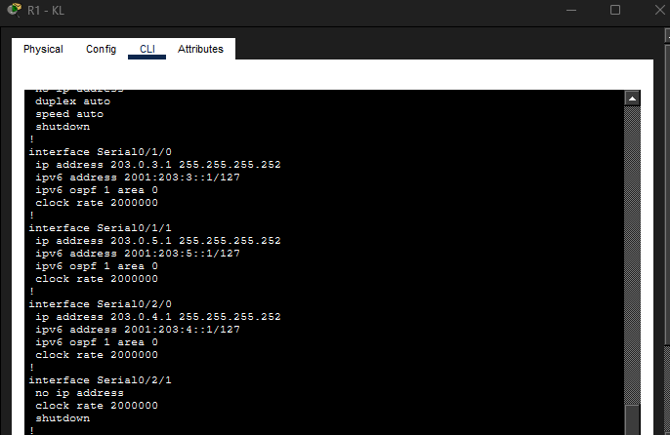
On all the serial port that is connected to the “Spokes”, the IPv4 and IPv6 address for each network between the “Hub” and “Spoke” is configured according to the IP addressing table with the first usable IP. The port is activated using the command “no shutdown”.

Example of configuration made on R1-Penang, one of the “Spoke”:
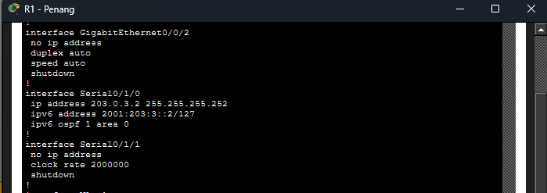
The port Serial0/1/0 is connected to R1-KL, the “Hub”. It is configured with IPv4 and IPv6 address of the second usable IP address that is on the same network with the “Hub” following the IP addressing table. The port is also activated using the command “no shutdown”.

5.2 LAN

5.2.1 Internal Links

5.2.1.1 Explanation
Internal Infrastructure: R2 and R3 Routing Configuration
The R2 and R3 routers serve as the anchors for the internal network architecture of each regional site, which includes JB, Malacca, Penang, and KL. These devices function as the main data conduit between the site's gateway to the outside world and the end-user LAN segments, operating inside the Distribution and Core layers of the local hierarchy.
Redundancy and Reliability
The use of a partial mesh topology is a crucial component of R2 and R3's design. The network removes single points of failure from the site architecture by setting up several inter-router linkages for example: R1 to R2, R1 to R3, and R2 to R3. This guarantees high availability; traffic is immediately redirected via the backup route to keep connected to the WAN hub in the event that a single internal link or router fails. These routers use Gigabit Ethernet interfaces, which offer the low-latency, high-bandwidth performance needed for contemporary local area networks, to handle this large volume of internal traffic.
Addressing and Security Standards
Private IP addressing, which separates internal site traffic from the public internet, is the cornerstone of R2 and R3's logical setup. The routers use the 10.255.x.x/30 range for IPv4, which is a common technique for point-to-point router lines that saves address space and adds a layer of protection by preventing routing. Likewise, Unique Local Addresses (ULA) with the prefix fd00:db8::/127 are used in the IPv6 implementation. In order to prevent neighbour discovery cache depletion attacks, the network adheres to RFC 6164 standards by internally adopting the /127 prefix length. This keeps the internal core safe from both internal and external threats.

5.2.1.2 Configuration
Example of configuration made on R1-Malacca:
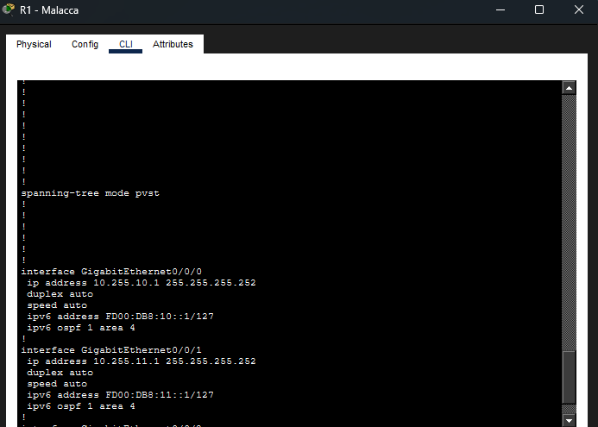
Both G0/0/0 and G0/0/1 are configured with the IPv4 and IPv6 address for R2 and R3 respectively as an internal link network following the IP addressing table by using the first usable IP. The command “no shutdown” is configured to activate both the port.

Example of configuration made on R3-Malacca:
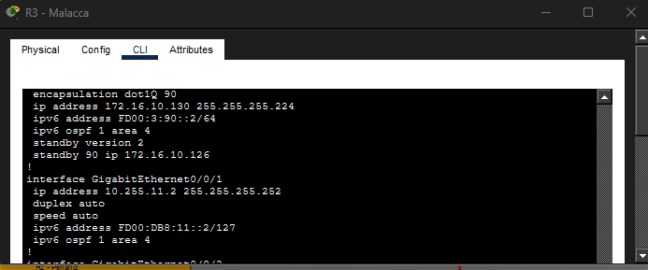
On the port G0/0/1 that is connected to R1-Malacca, the second usable IPv4 and IPv6 addresses is configured that is on the same network of the R1-Malacca following the IP addressing table. “no shutdown” is entered to activate the port.

5.2.2 Router-on-a-Stick (ROAS)

5.2.2.1 Explanation
Implementation
In order to offer effective inter-VLAN routing, the internal local area network is constructed utilizing the Router-on-a-Stick (ROAS) concept. By acting as the centralized gateways for all departmental traffic, the R2 and R3 routers in this design provide safe communication between devices in various broadcast domains.
Logical Segmentation via Sub-interfaces
The routers make use of logical sub-interfaces rather than distinct physical interfaces for each network. The core routers can manage many subnets at once by splitting a single physical GigabitEthernet port into multiple virtual ports for example: G0/0/0.10, G0/0/0.20, and G0/0/0.30. Every sub-interface has a distinct IP address that serves as the Default Gateway for a particular VLAN, such as the server, management, or Internet of Things segments.
VLAN Tagging and Encapsulation
The routers use IEEE 802.1Q encapsulation to differentiate between traffic from various departments. When information moves from a switch to a router, it bears a "VLAN tag." In order to prevent data from the "Server" VLAN from leaking into the "IoT" VLAN unless it is properly routed, the sub-interfaces on R2 and R3 are set up to recognize these particular tags. This guarantees logical isolation and organization of high-speed internal traffic.
Switch Trunking Integration
The setup of the 2960-series switches determines how well the Router-on-a-Stick concept works. Trunk Port is the configuration for the link that connects the switch and router. The trunk port functions as a multiplexed highway, enabling all VLAN traffic to travel to the R2 or R3 sub-interfaces over a single cable, in contrast to a regular access port that only transmits one VLAN. In addition to simplifying the physical infrastructure and drastically lowering the amount of cabling needed, this offers the scalability required for future department growth.

5.2.2.2 Configuration
Example of configuration made on R2-JB:
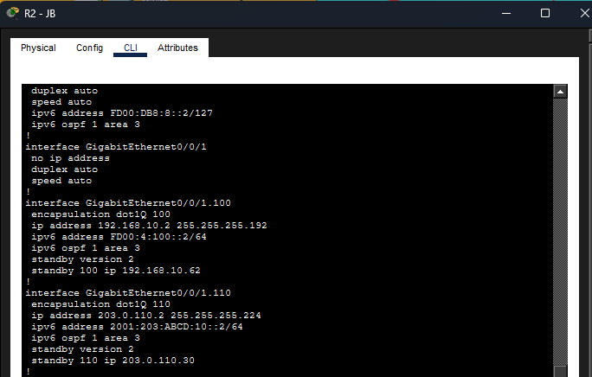
The port G0/0/1.100 and G0/0/0.110 is configured with the IPv4 and IPv6 address of the department’s VLAN network to facilitate Router-on-a-Stick communication. Both of this sub-interface is configured with 802.1Q encapsulation with “encapsulation dot1Q 100/110” to identify the route traffic belonging to the specific VLAN. R3-JB has the same configuration with the difference being an incremented IP address.

Example of configuration made on JB-MSwitch:
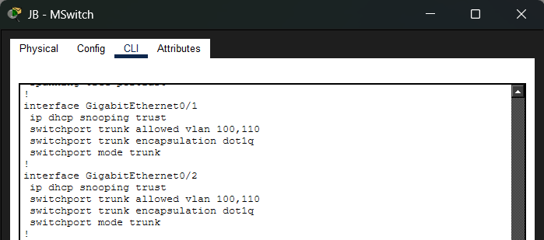
On the JB multilayer switch, GigabitEthernet0/1 and GigabitEthernet0/2 are configured as trunk ports to carry multiple VLANs between switches. Both interfaces are set to trunk mode using 802.1Q encapsulation and are allowed to pass VLAN 100 and VLAN 110 traffic.

5.3 OSPF

5.3.1 Explanation
OSPF Dynamic Routing
OSPF (Open Shortest Path First) is used as the dynamic routing protocol to guarantee smooth communication throughout the entire company network. This eliminates the need for manual intervention by enabling the routers to automatically exchange their local network information across several sites.
OSPF Area Hierarchy
To reduce routing cost and maximize efficiency, the network is segmented into several regions. While regional sites are given distinct areas such as area 1 for KL, area 2 for Penang, area 3 for JB, area 4 for Malacca, to keep local routing updates limited, area 0 acts as the backbone for WAN lines.
Internal Link Propagation
The OSPF process includes all physical interfaces that connect the core routers to the edge, including Gig0/0/0 on R2-JB. Internal traffic can now reach the remainder of the corporate network through the neighbour adjacencies that R2 and R3 can create with R1.
VLAN Network Advertisement
The departmental networks specified under the Router-on-a-Stick sub-interfaces are included in the OSPF configuration on the core routers, which goes beyond physical linkages. The routers advertise local subnets for Management, Servers, and IoT to the entire business by including logical sub-interfaces such as G0/0/1.100 and G0/0/1.110 in the OSPF process.
OSPFv3 for IPv6 Integration
The routers use OSPFv3 to manage both IPv4 and IPv6 routing. For example, to make sure that its distinct IPv6 prefix is accessible from other states, sub-interface G0/0/1.100 is explicitly added to ipv6 ospf 1 area 3. All internal services within the private network architecture are guaranteed to be globally accessible thanks to this dual-stack strategy.

5.3.2 Configuration
KL OSPF Configuration Table
Device Name | Router ID | Area
R1-KL | 1.1.1.1 | 0&1
R2-KL | 2.2.2.2 | 1
R3-KL | 3.3.3.3 | 1

Penang OSPF Configuration Table
Device Name | Router ID | Area
R1-Penang | 6.6.6.1 | 0&2
R2-Penang | 6.6.6.2 | 2
R3-Penang | 6.6.6.3 | 2

JB OSPF Configuration Table
Device Name | Router ID | Area
R1-JB | 5.5.5.1 | 0&3
R2-JB | 5.5.5.2 | 3
R3-JB | 5.5.5.3 | 3

Malacca OSPF Configuration Table
Device Name | Router ID | Area
R1-Malacca | 4.4.4.1 | 0&4
R2-Malacca | 4.4.4.2 | 4
R3-Malacca | 4.4.4.3 | 4

Example of configuration made on R1-KL:
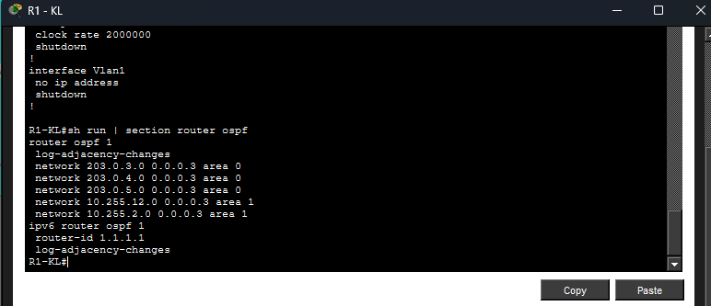
For IPv4 OSPF configuration, it is configured with “router ospf 1” where the 1 being the process ID. Router ID is set following the OSPF Configuration Table with the command “router-id 1.1.1.1”. All network connected to the router is then added with “network 203.0.3.0 0.0.0.3 area 0”. The “0.0.0.3” is the calculated by 255.255.255.255 - the subnet mask which is 255.255.255.252 in this case. The area is set to 0 to serve as a backbone as mentioned above, area 1 is the area used for KL site, where area 2 is for Penang, area 3 for JB, and area 4 for Malacca.
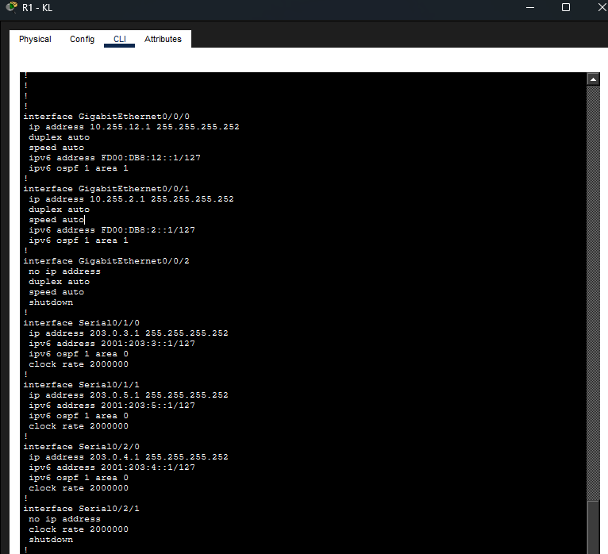
The router ID for IPv6 OSPF is configured by using “ipv6 router ospf 1” then “router-id 1.1.1.1” following the table. For each interface on the router, “ipv6 ospf 1 area x” is entered to enable OSPF for IPv6 where area 0 for backbone (WAN) and area 1 for KL site.

Example of configuration made on R2-Penang:
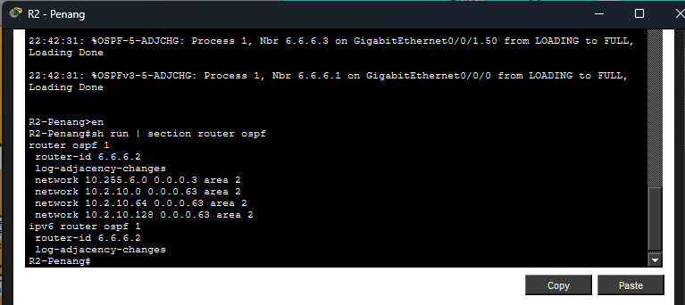
Just like the R1 of KL, a unique router ID is assigned to this router: “6.6.6.2”. All the network on the router’s interface are configured under area 2 which is the area for Penang site.
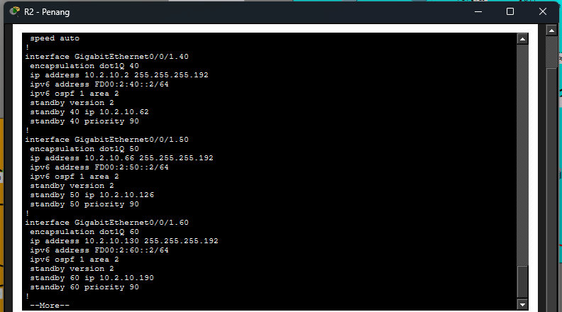
IPv6 OSPF is also configured with the router ID: “6.6.6.2”. “ipv6 ospf 1 area 2” command is configured on all interfaces.

6.0 WLAN Architecture

6.1 Penang Branch
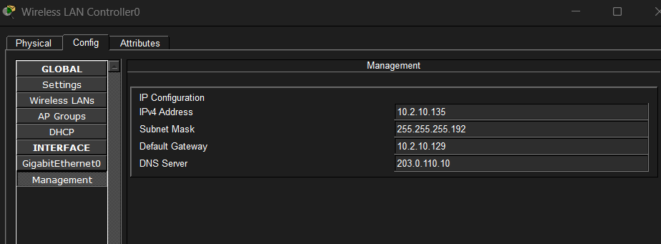
The Wireless LAN Controller (WLC) management interface received its configuration through VLAN 60 which serves the WLAN system architecture that users proposed. The following parameters were assigned:
- IP Address: 10.2.10.135
- Subnet Mask: 255.255.255.192
- Default Gateway: 10.2.10.129
- DNS Server: 203.0.110.10
The management IP resides in subnet 10.2.10.128/26 which belongs to VLAN 60 thus the WLC maintains wireless network accessibility from its location. The default gateway allows all network devices to connect with other company branches as well as the main server center.
The WLC configuration shows a scalable centralized WLAN architecture through its support for VLAN segmentation and secure wireless management even though AccessPoint-PT operates in autonomous mode at present.
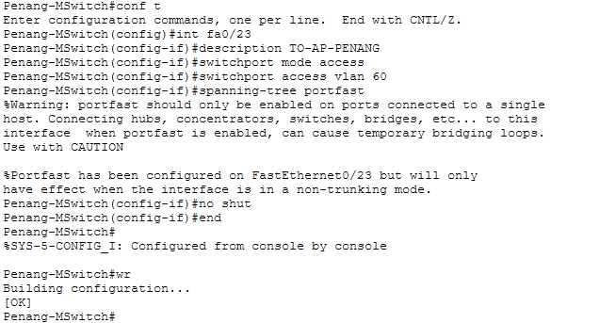
The Access Point connection to switch port Fa0/23 required access mode configuration with VLAN 60 assignment to direct all wireless data through the Delivery department network which uses 10.2.10.128/26 as its subnet. PortFast activation enabled the interface to jump straight into its forwarding state which shortened the time needed for AP connections. The network structure of Penang branch operates with correct VLAN separation which delivers continuous wireless network operation.

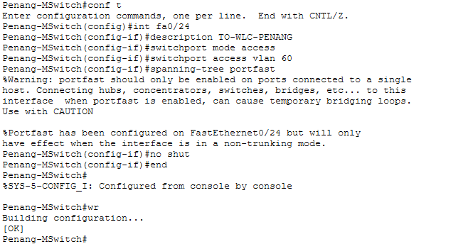
The switch port which connects to the Wireless LAN Controller (Fa0/24) operates in access mode while it belongs to VLAN 60 for WLC operation inside Delivery department subnet (10.2.10.128/26). The system enables PortFast which lets it start forwarding immediately while it shortens the time needed for startup. The configuration enables the WLC to establish proper connections with access points and wireless clients which exist in its VLAN segment.
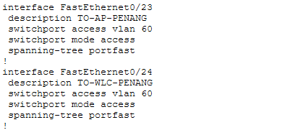
The show run output verifies that both FastEthernet0/23 and FastEthernet0/24 were successfully configured in access mode and assigned to VLAN 60. The Access Point establishes a connection through FastEthernet0/23 while FastEthernet0/24 serves as the connection point for the Wireless LAN Controller. The network activates PortFast on both interfaces because they require immediate forwarding state activation. The AP together with WLC operates inside VLAN 60 which proves their correct network placement because it enables proper wireless traffic management through Penang branch network communication.

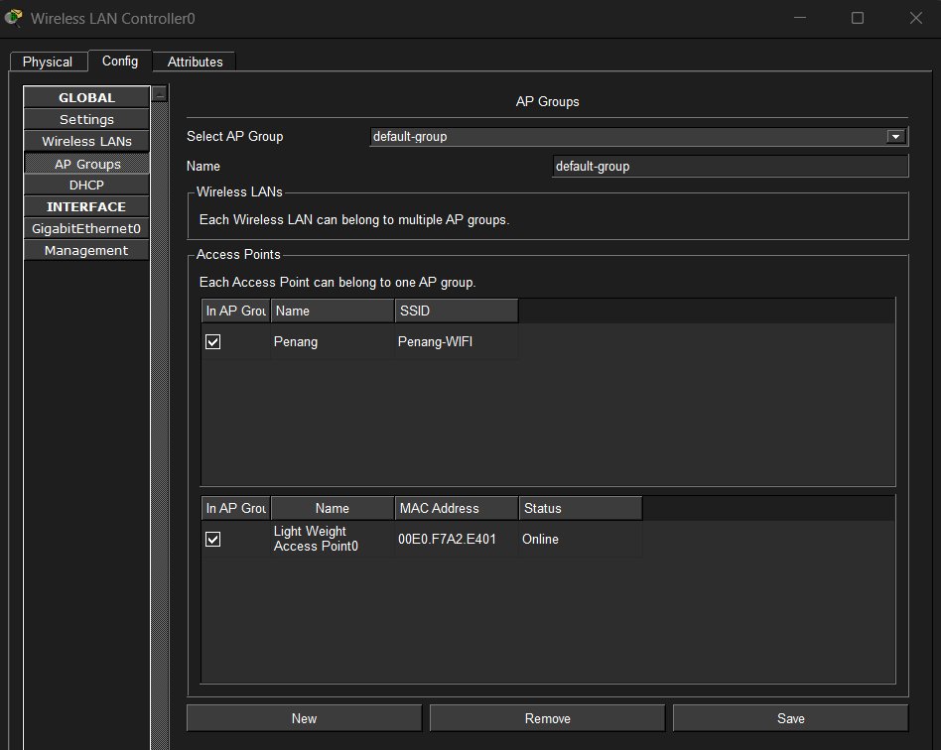
The configuration of WLC AP Group shows that the SSID "Penang-WIFI" belongs to the default AP group while the access point maintains an active online connection. The information proves that the AP maintains its correct position within the WLC system while it actively transmits the designated WLAN to serve wireless clients at Penang branch.

6.2 JB Branch
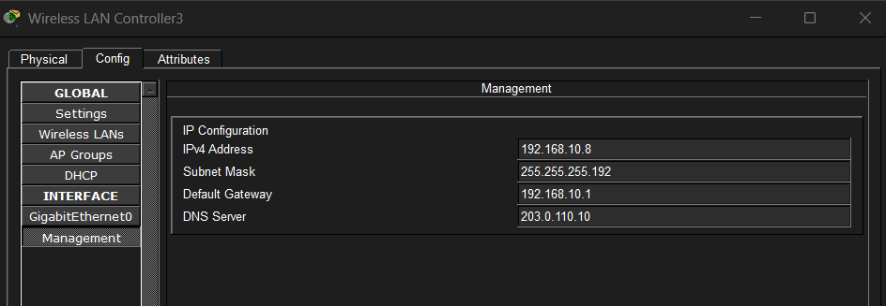
The WLC management interface in the JB branch was configured with IP address 192.168.10.8/26 under VLAN 100 (IT Department). The network uses 192.168.10.1 as its default gateway to connect different segments through router-on-a-stick operations. The DNS server 203.0.110.10 enables users to discover names through its name resolution service. The configuration establishes correct network links which allows JB branch to centralize its wireless network administration.
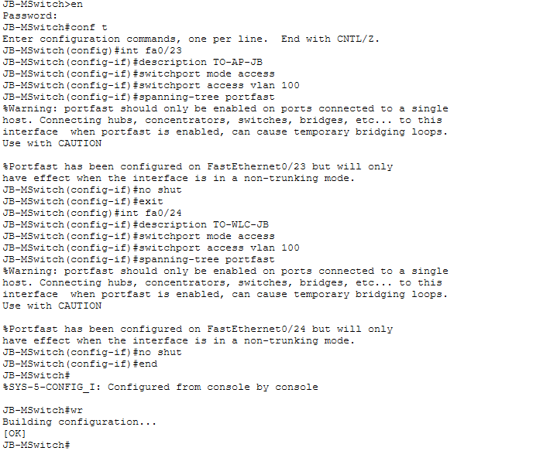
The JB branch contains two switch ports which support the Access Point through Fa0/23 and Wireless LAN Controller through Fa0/24. The switch ports operate in access mode while they belong to VLAN 100 which serves the IT Department network. The PortFast function enables devices to reach their forwarding state immediately which shortens the time it takes for them to connect during startup. The AP and WLC operate within their designated VLAN segment because this configuration enable them to communicate properly which supports wireless operations in the JB branch.
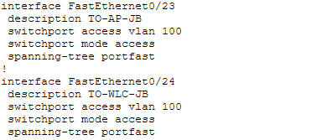
The output from the show run command verifies that FastEthernet0/23 and FastEthernet0/24 operate as access ports for AP-JB and WLC-JB respectively through their appropriate setup in VLAN 100 which enables PortFast functionality. The verification process confirmed that both devices required placement within the IT network segment while JB branch needed to maintain its wireless network stability.

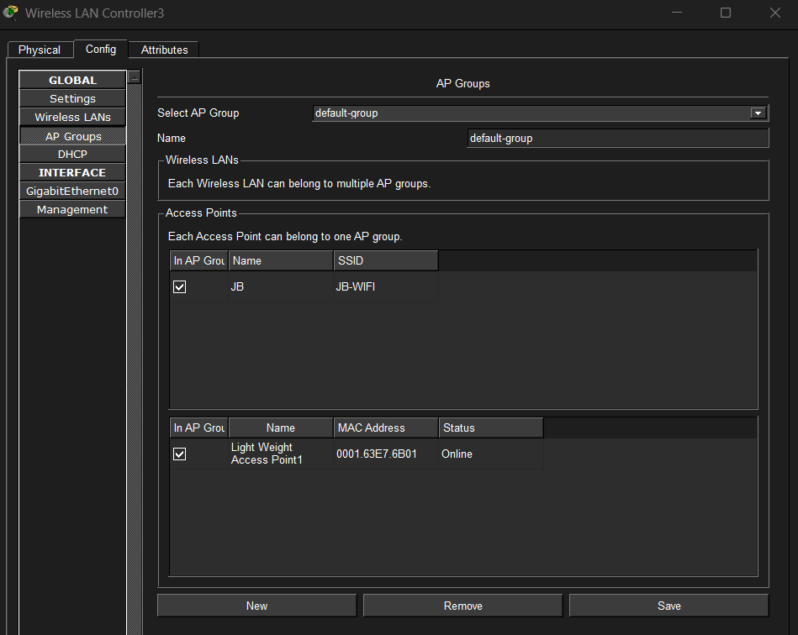
The AP Group setup on the WLC reveals that the default AP group holds the SSID "JB-WIFI" and the lightweight access point achieved online status through successful joining. The WLC establishes proper links with the AP which transmits the JB branch WLAN information through its configured WLAN broadcast system.

7.0 EtherChannel

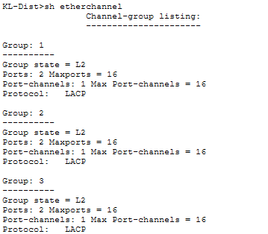
The show etherchannel command output is a tool used to show the existing configuration of the EtherChannel in the switch. According to the output, three Etherchannel groups are set up Group 1, Group 2, and Group 3.
All the groups are running in Layer 2 (L2) mode meaning that the bundled interfaces are switchports and are used to switch as opposed to routing. This is normally employed in linking switches to each other to amplify bandwidth and offer redundancy.
Each group contains 2 physical ports which are joined together as one logical interface known as Port-Channel. The output displays Ports: 2 which means that there are two physical interfaces that are actively involved in the EtherChannel bundle. The switch has a maximum of 16 ports/group (Maxports =16) and 16 port-channel interfaces (Max Port-channels = 16).
The one is LACP (Link Aggregation Control Protocol). LACP is a dynamic negotiation protocol that is specified in IEEE 802.3ad (since renamed 802.1AX) and which is used to create and maintain the EtherChannel. It makes both sides of the connection agree on the bundling configuration minimizing configuration errors in comparison to static EtherChannel.
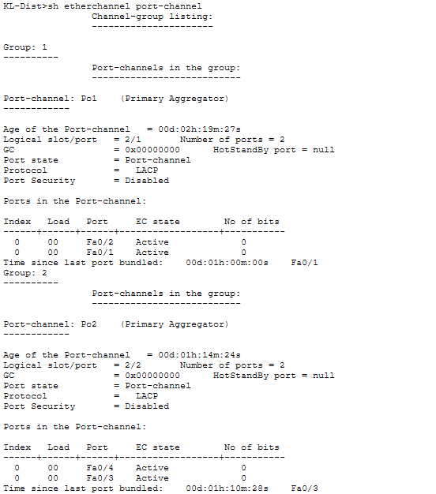
The show etherchannel port-channel port-channel command shows a lot of information regarding the configured Port-Channel interfaces on the switch. Out of the result, two Etherchannel groups were represented namely Group 1(Po1) and Group 2 (Po2). This output confirms that PO1 and PO2 are configured as and used LACP to maintain the link aggregation.

8.0 HSRP Implementation
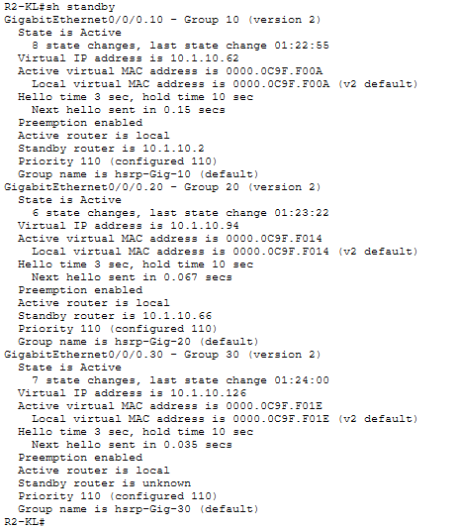
The following command provides the status of standby of the router R2-KL where state is active and the standby router ip is 10.1.10.2 and also shown priority of active is 110.

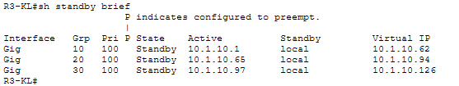
The command shows an overview of HSRP on R3-KL show standby brief. As shown in the output R3 is a standby router where the priority is 100.
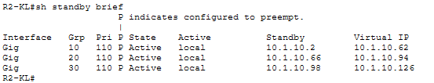
The following command provides an overview of the HSRP (Hot Standby Router Protocol) set up on router R2-KL show standby brief.
HSRP is a redundancy protocol which permits more than one router to share a virtual IP address, which ensures there is no loss of network when any router fails.
As shown in the output, three HSRP groups are prepared on Gigabit interfaces; Group 10, Group 20 and Group 30. This setup indicates that there are three VLANs or subnets which R2-KL is set up to act as the Active gateway router. As preemption is turned on and the priority of R2-KL is 110 that, in case of going down and then coming up online R2-KL will be automatically granted the Active state assuming that its priority is higher than the current one.

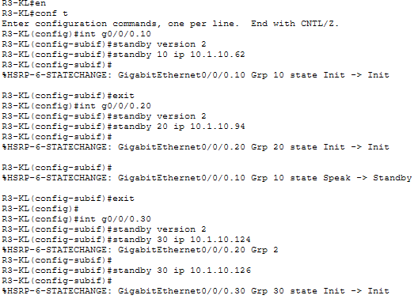
The image provided is the steps for configuring on standby router where standby version 2 is used for this HSRP configuration. Next, a virtual IP of 10.1.10.62, 10.1.10.94, 10.1.10.124 for this standby router is provided in this case.

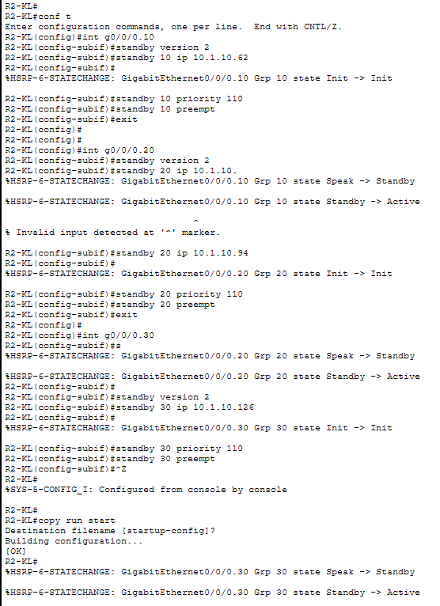
The following command are about steps of configuration of active standby. standby version 2 is used for this HSRP configuration. And set the priority higher than the standby which is 110 as priority. As result the state of the router from speak changed to standby and changed to active.

9.0 Server Services
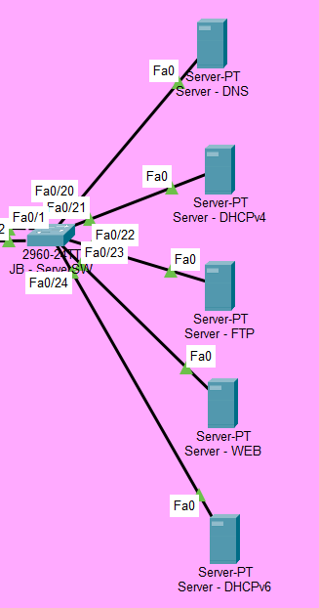
This is the server farm in the network topology as shown in this figure.

9.1 DNS Server
The Domain Name System (DNS) serves as the Internet's directory by converting human-readable domain names into machine-readable IP addresses, which facilitates web browsers' ability to locate and load content from websites. People would have to remember complex IP addresses in the absence of DNS. (Kimanzi, 2018)

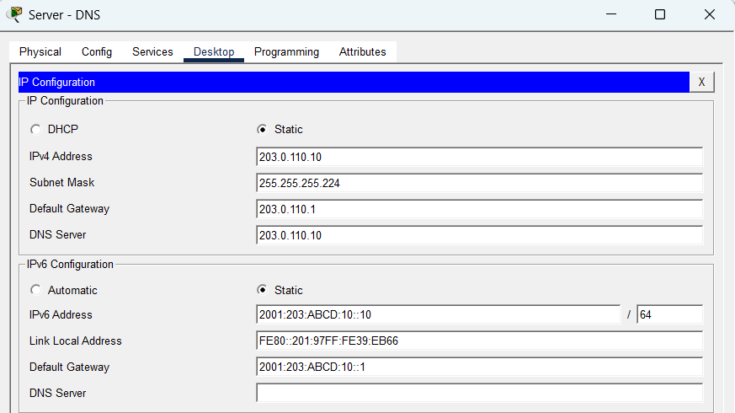The IPv4 Address, Subnet Mask, Default Gateway and DNS Server are assigned with as shown in figure. Since this server is used as a DNS server, its IPv4 address and the IP address of the DNS server are the same. In addition, the IPv6 configuration is also shown in figure.

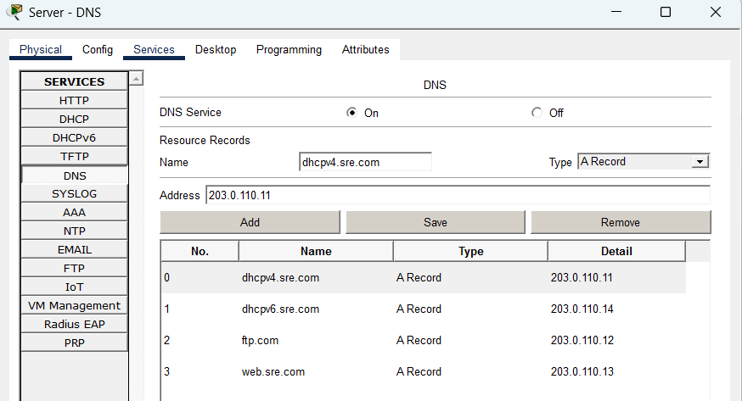
The DNS service is turned On, and several A Records have been created. Every record applies an IP address with a domain name. For example: a website named “web.sre.com” and its IP address is added into the server, so that the DNS server will resolve “web.com” into an IP address of 203.0.110.13.

9.1.1 DNS Testing
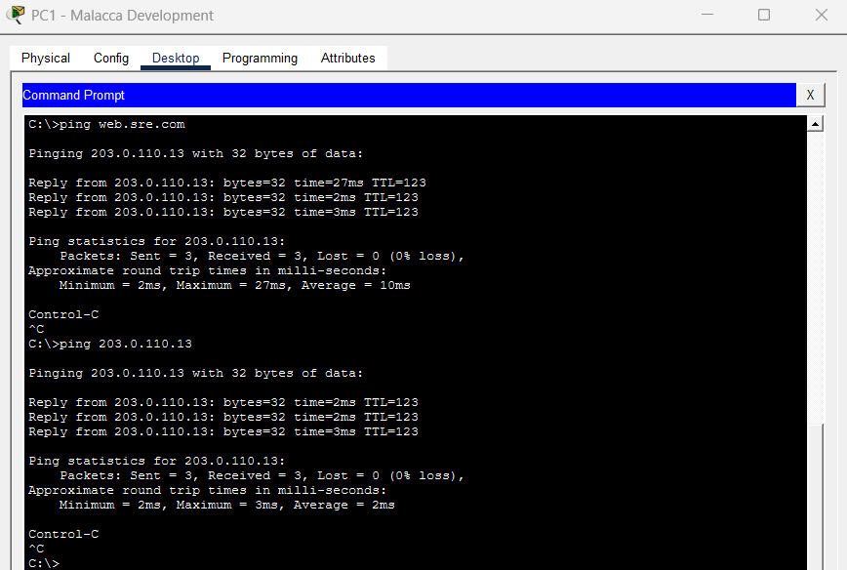
Users can ping the Web Server using the domain-name or IP address in any PC. This is because when a user pings a domain name, the DNS server determines which server they will access by converting name requests into IP addresses.

9.2 FTP Server
The File Transfer Protocol (FTP) is a protocol used in computer networks to efficiently move data between a client and a server. On a distant server, it enables users to upload, download, edit, and remove files. In order to access shared files, the client connects to the FTP server using a username and password. (Panchal, 2023)

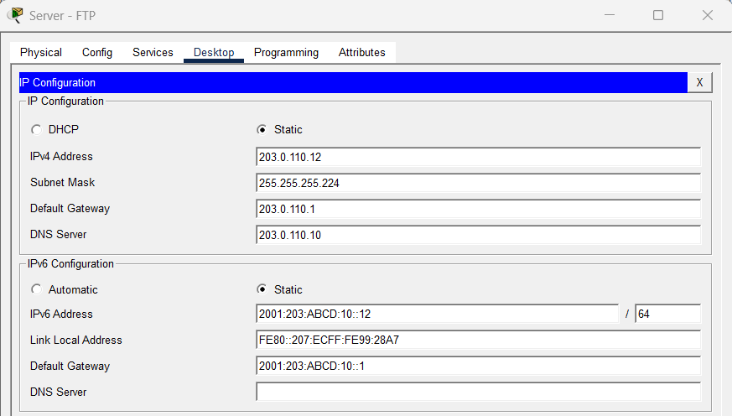The FTP server has been configured with the IPv4 address and IPv6 address as shown in the figure.

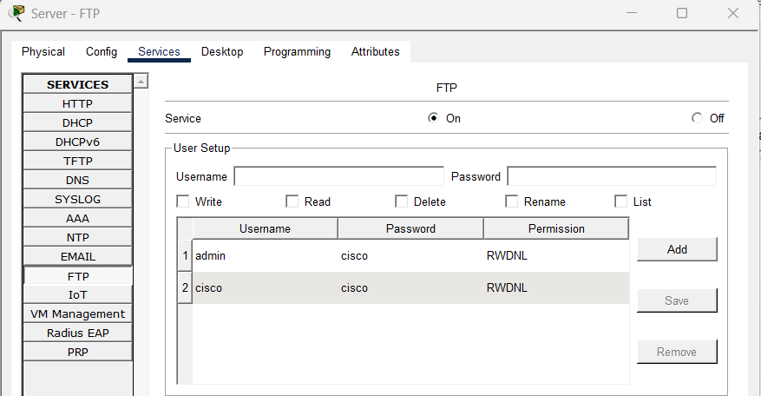The FTP service is turned On, and a user account named cisco has been created with the password cisco Users are assigned with all permissions, which include the ability to write, read, delete, rename, and list files and directories.

9.2.1 FTP Testing
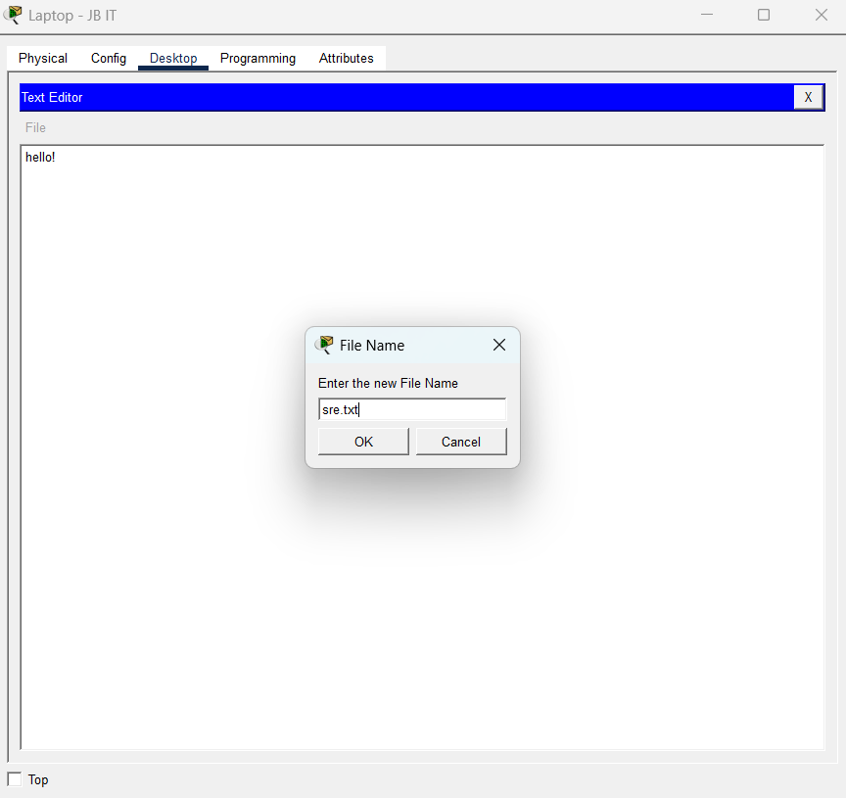
User can create a new text file in order to put it into FTP later.

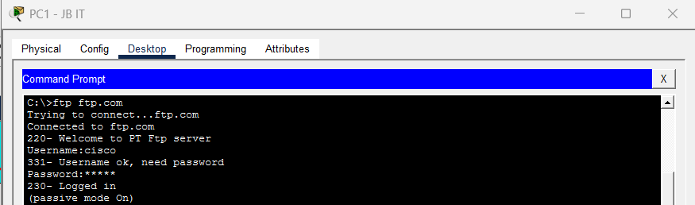
Users need to input the username and password when connect to the FTP server to access the FTP server.

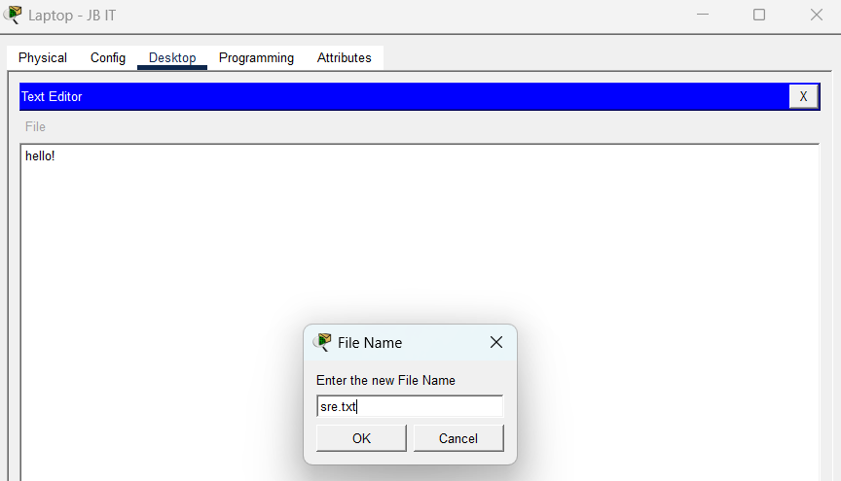

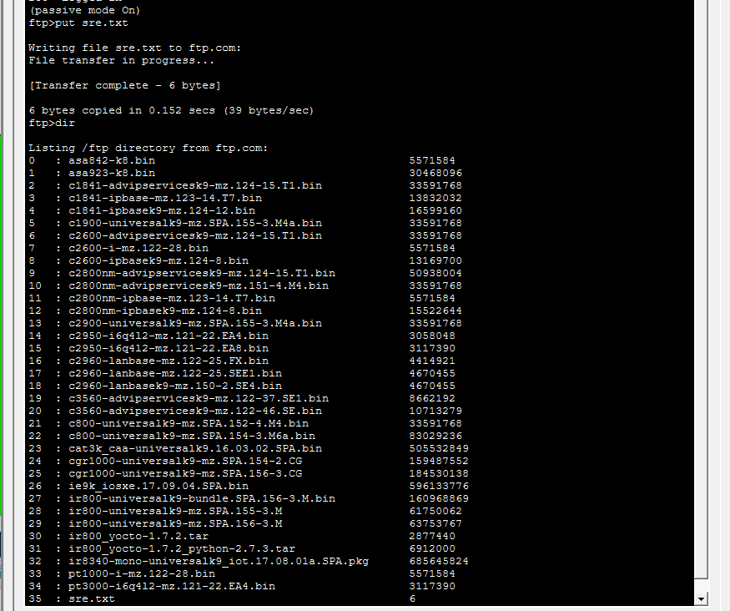
The user can also create a new file with some contents and upload successfully to the FTP server which is figure shown above. So that the file from the FTP server can be downloaded and viewed by the other user on a different PC. User can use dir command to view the directory.

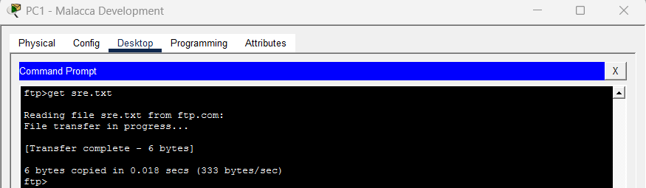
The figure shown above is the user download the “sre.txt” files from the FTP server. The FTP server allows users to carry out lots of commands, including uploading, editing, downloading, and deleting files.

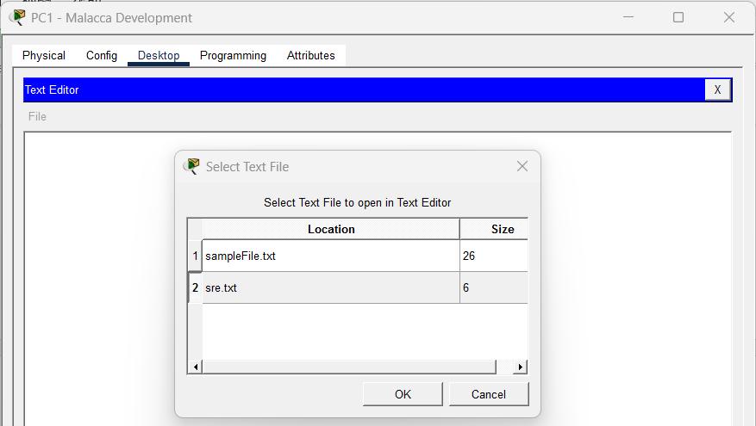
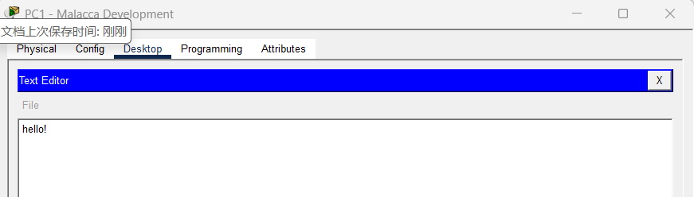
After downloading the text file, user can proceed to text editor to open and edit the text file.

9.3 Web Server
A web server is a server that provides a user with a webpage when requested through a browser. In reality, when we browse the internet, we request a file or web page from a web server. (Alexander, 2024)

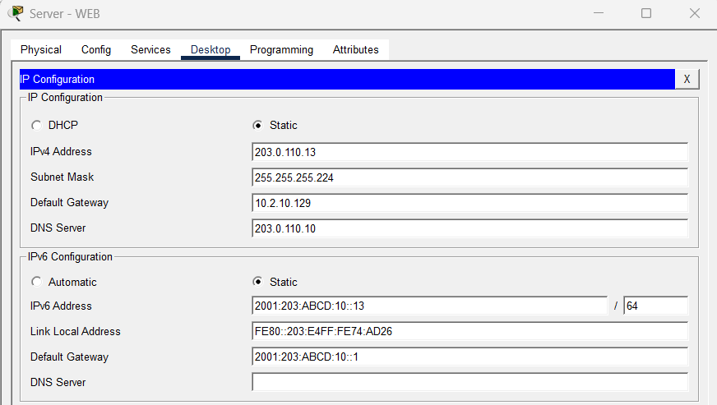The Web server has been configured with the IPv4 address and IPv6 address as shown in the figure.

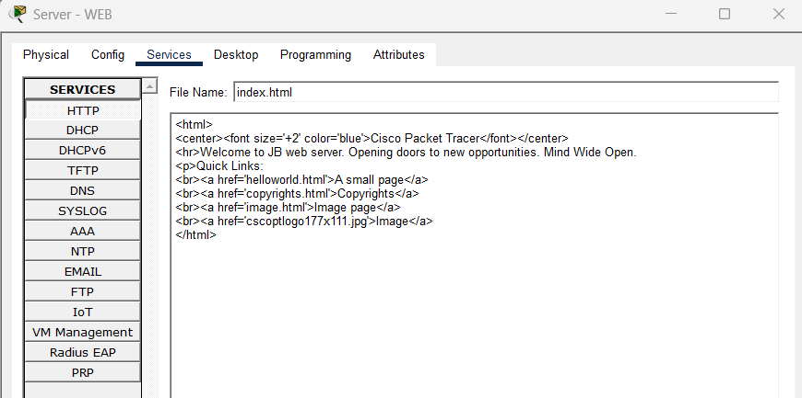In this Web server, the “index.html” file is edited with the content in the HTTP services which is shown above.

9.3.1 Web Testing
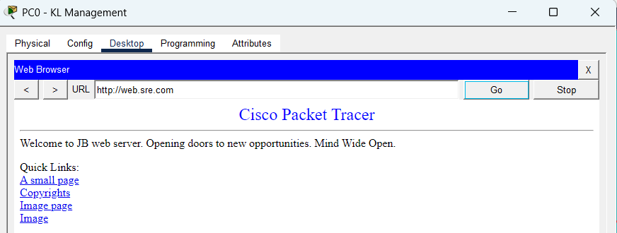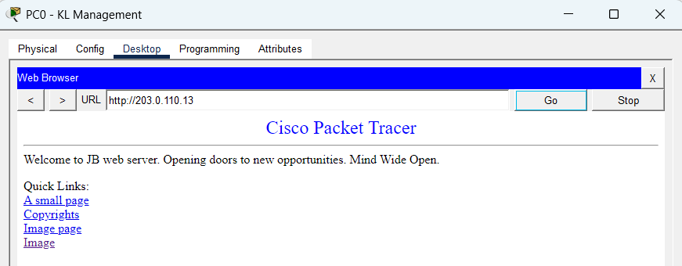
When entering the IP address of the Web server or the URL "web.sre.com." using a web browser, Users can visit the Web server on any PC.

9.4 DHCP Server
DHCP (Dynamic Host Configuration Protocol) is a network service that automatically assigns IP configuration to devices, including the IP address, subnet mask, default gateway, and DNS server. Instead of manually configuring each client device, the DHCP server handles this process dynamically, making network setup faster, easier, and less prone to errors. (Ramadhani, 2025)
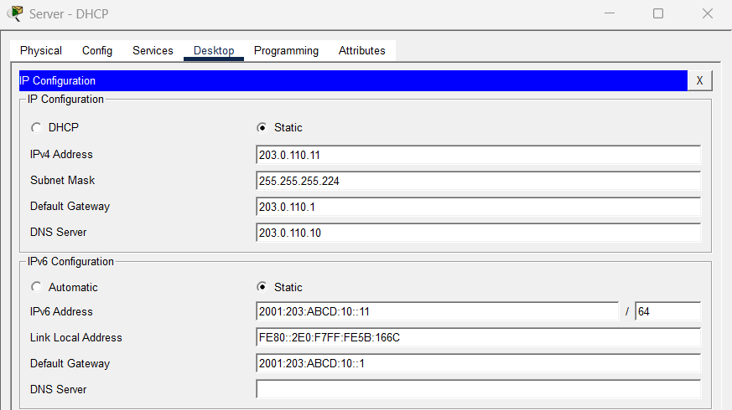 The DHCP server has been configured with the IPv4 address and IPv6 address as shown in the figure.
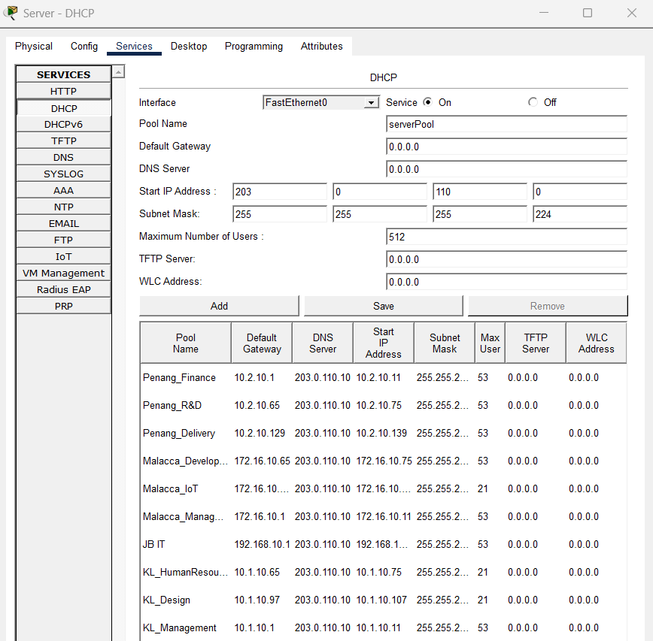
The DHCP service is turned On, and multiple DHCP pools have been created for different departments and locations. Each pool is configured with a default gateway, DNS server, start IP address, subnet mask, and maximum number of users.

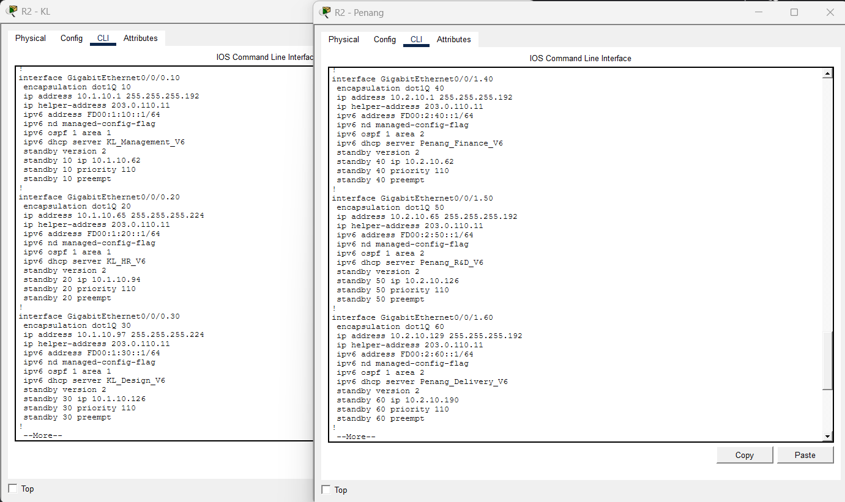
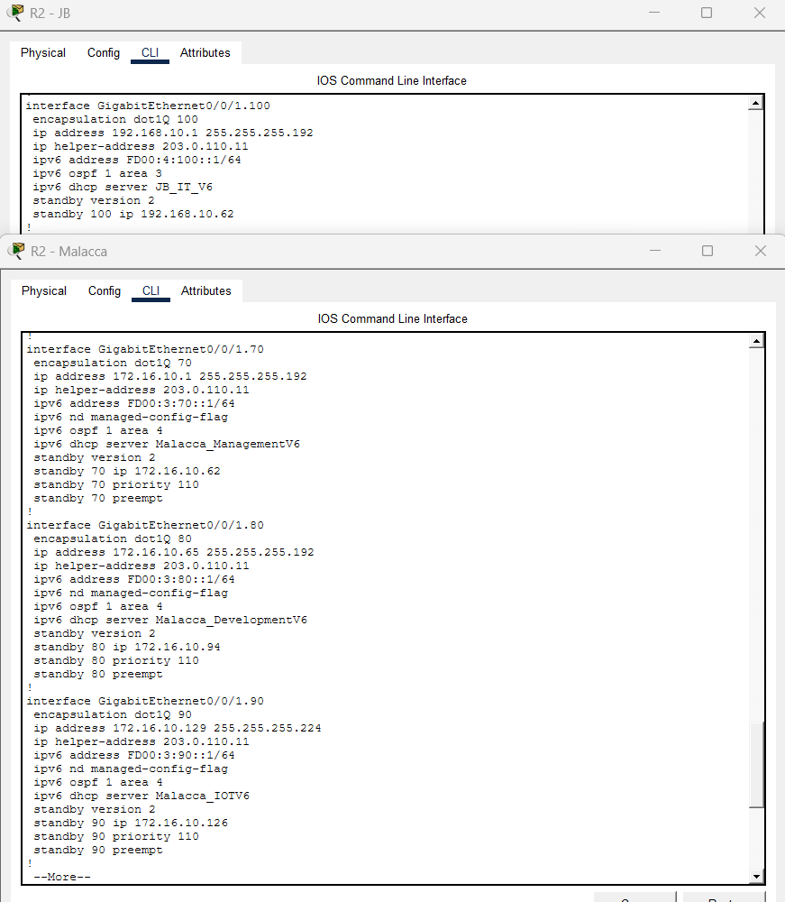

The IP helper-address command is configured on all router to specify the IP address of the DHCP server. Its function is to forward DHCP broadcast requests from clients in the local subnet to the remote DHCP server located in a different network.

9.4.1 DHCP Testing
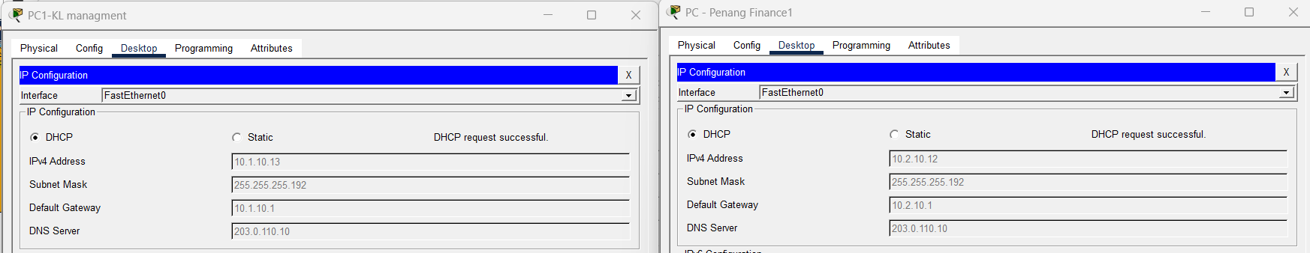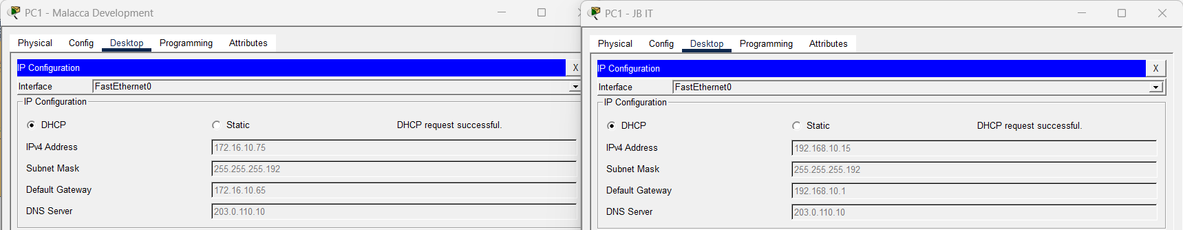
All PCs successfully obtaining the IP Configuration from the DHCP server. Each PC received a valid IPv4 address, subnet mask, default gateway, and DNS server.

9.5 DHCPv6 Server
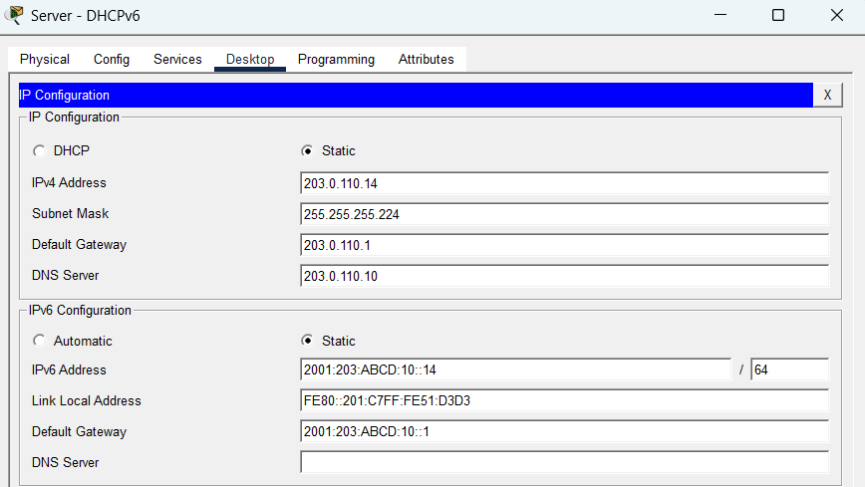
The DHCPv6 server has been configured with the IPv4 address and IPv6 address as shown in the figure.

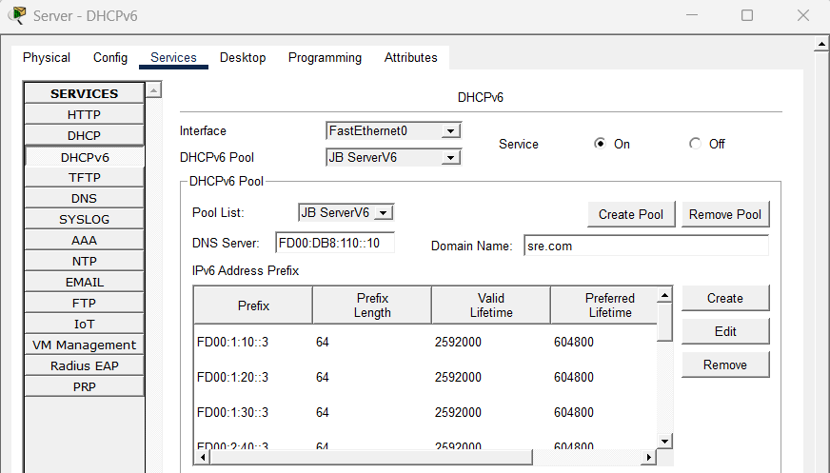
The DHCPv6 pool named JB ServerV6 is configured to provide IPv6 address configuration to clients. It includes multiple IPv6 Address Prefix and its length, along with valid lifetime and preferred lifetimes. Its allowing devices to automatically receive their IPv6 address from the DHCPv6 server.

The ipv6 nd managed-config-flag command was added to the router interface to instruct IPv6 clients to obtain their IP address and network configuration from a DHCPv6 server. The ipv6 dhcp server command was also configured to bind a specific DHCPv6 pool to the interface, enabling the router to distribute IPv6 addresses.

9.5.1 DHCPv6 Testing
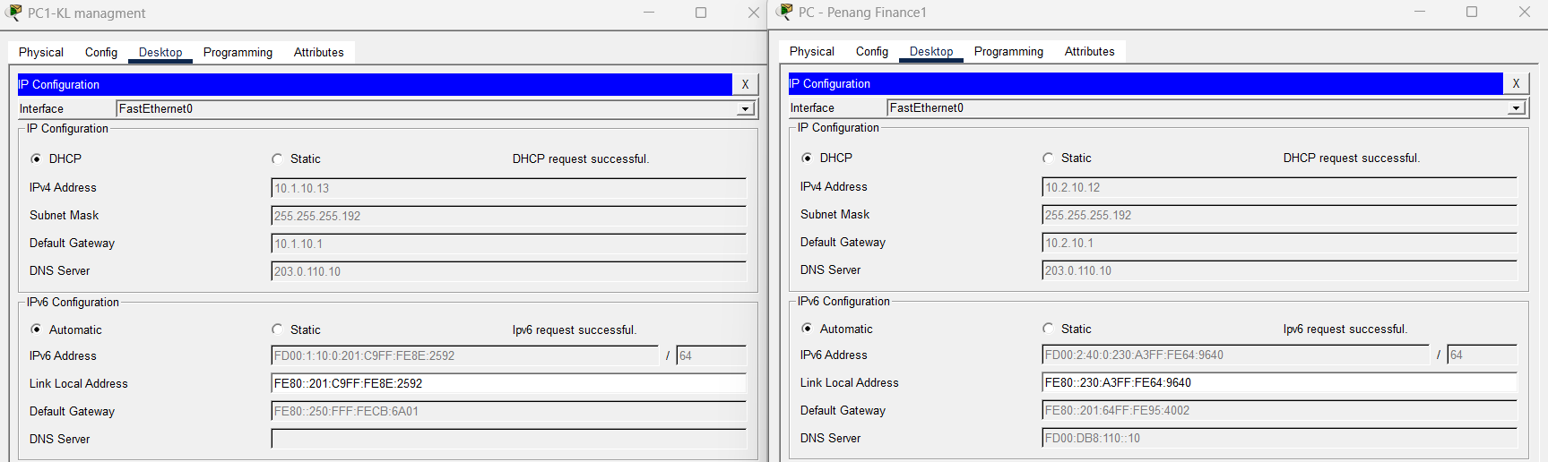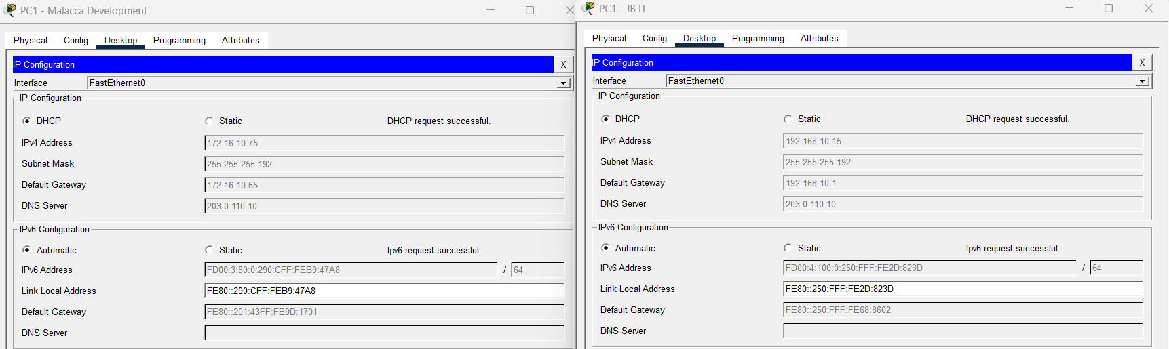
All PCs successfully obtaining the IP Configuration from the DHCPv6 server. Each PC received a valid IPv6 address, link local address and default gateway.

10.0 Tracert/Ping Commands
The ping command is used to test the network connectivity between two devices. To find out whether a response has been received, it sends echo request packets to a target IP address. If responses are received, it verifies that the network connection is working and the destination device is reachable.

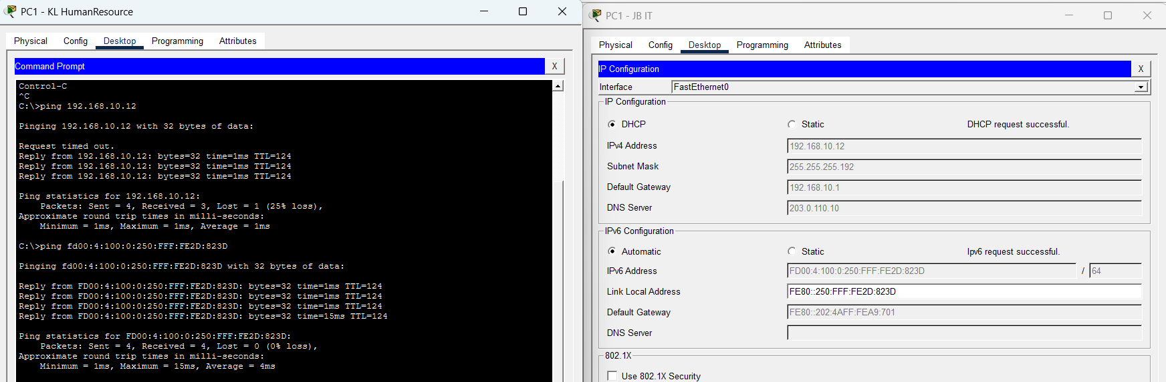
The PC in the KL site successfully ping both IPv4 and IPv6 addresses of the PC in the JB site. This confirms that network connectivity between the KL and JB sites is functioning properly.

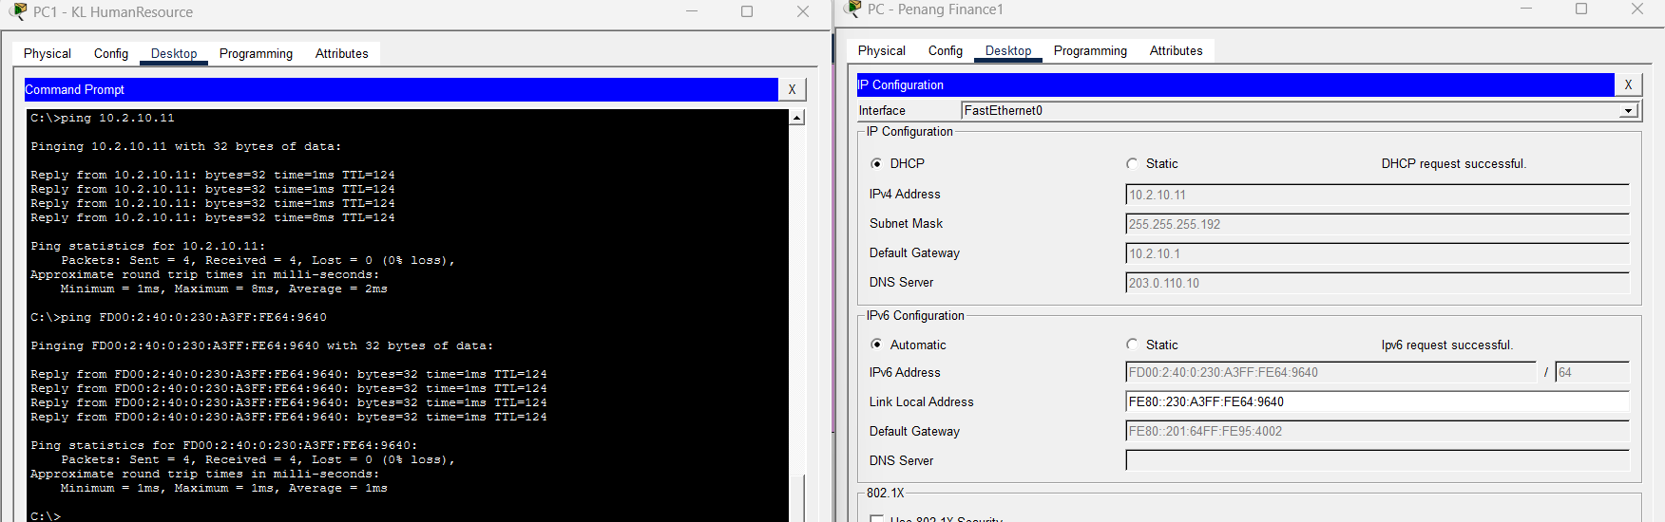
The PC in the KL site successfully ping both IPv4 and IPv6 addresses of the PC in the Penang site. This confirms that network connectivity between the KL and Penang sites is functioning properly.
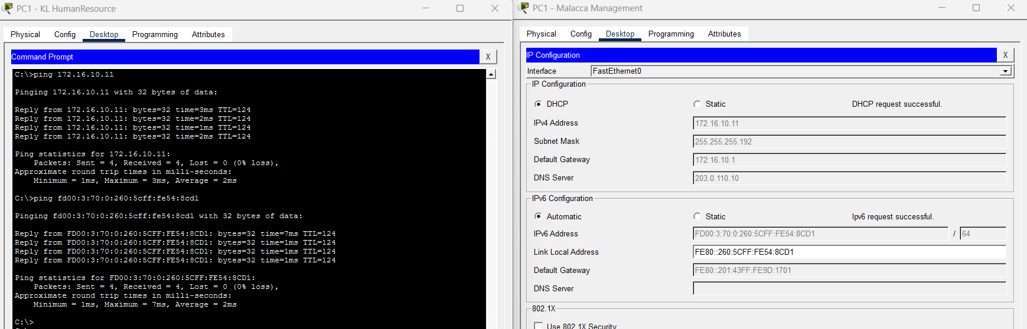
The PC in the KL site successfully ping both IPv4 and IPv6 addresses of the PC in the Malacca site. This confirms that network connectivity between the KL and Malacca sites is functioning properly.

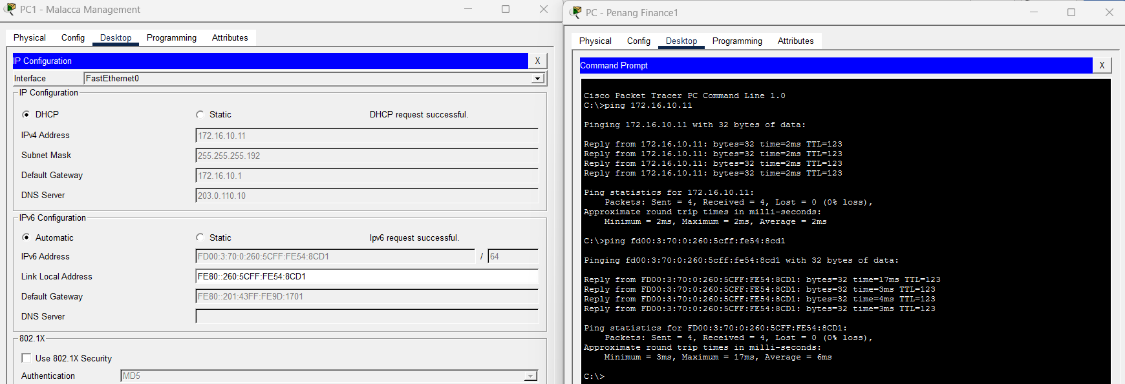
The PC in the Penang site successfully ping both IPv4 and IPv6 addresses of the PC in the Malacca site. This confirms that network connectivity between the Penang and Malacca sites is functioning properly.

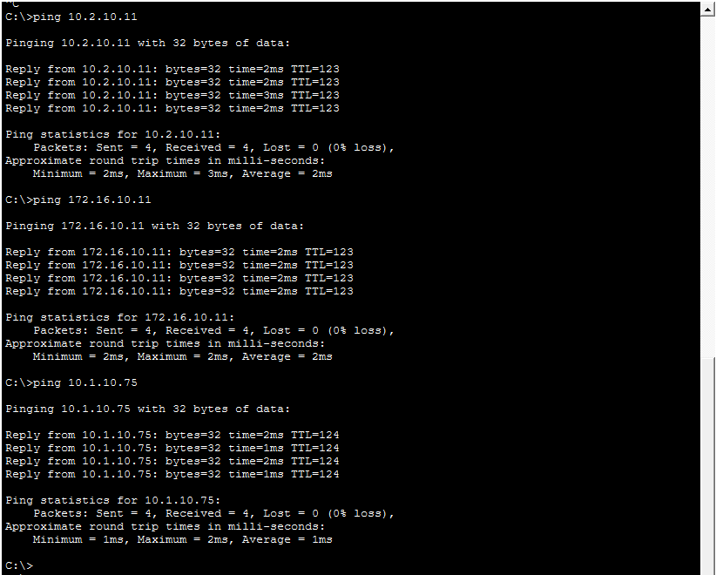
The DNS server successfully sent ICMP echo requests to PCs in the KL, JB, and Penang sites. All ping attempts received replies with 0% packet loss, confirming that network connectivity between the DNS server and the remote site PCs is functioning properly.

11.0 Security Mechanisms

11.1 Basic Router Configurations

11.1.1 Banner and Password Encryption
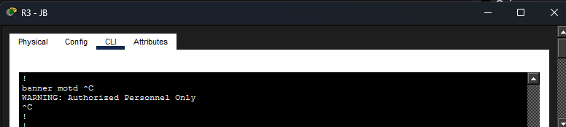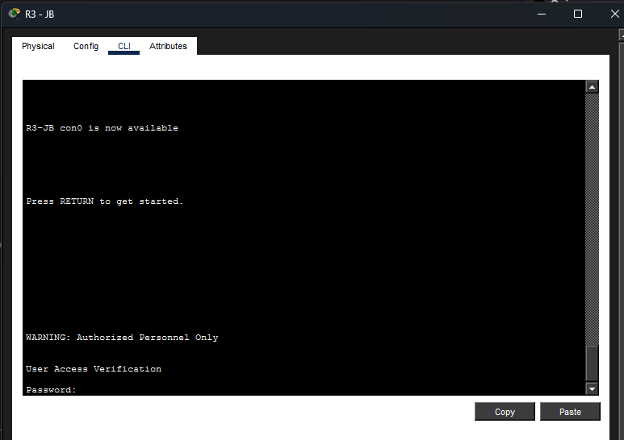
Banner is configured with the command: “banner motd # WARNING: Authorized Personnel Only#”. This will display a warning message to unauthorized users before logging in. It provides legal and security compliance and deters unauthorized access.
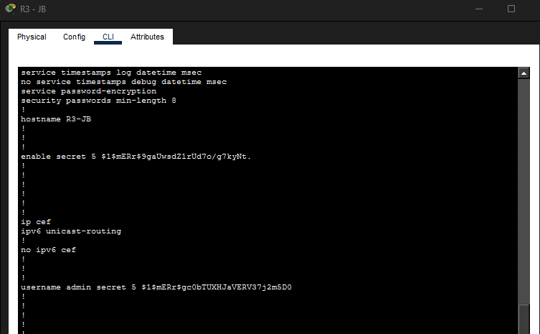
The command “service password-encryption” encrypts all plaintext passwords that is saved in the configuration. Where as the “security passwords min-length 8” command enforces strong password policy to prevent brute-force attacks. These commands protect administrative accounts and ensure passwords are encrypted.

11.1.2 Console Line Security
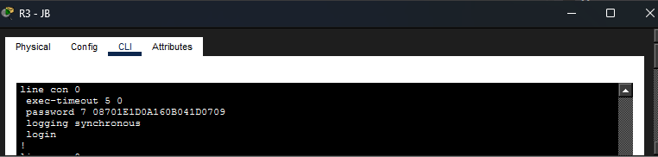
Password for console login is configured with “password 123console” and the command “login” enables the password check on the console. “exec-timeout 5 0” auto logs out idle session after 5 minutes, the 0 indicates 0 seconds. “logging synchronous” prevents the system messages from disrupting typed commands. These commands prevent unauthorized local access and idle sessions from being hijacked.

11.1.3 Privileged Access
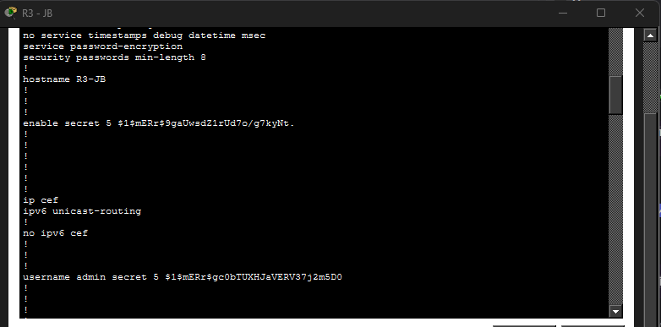
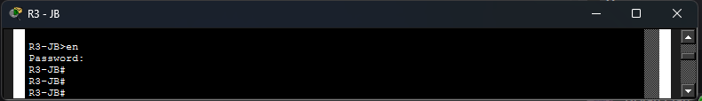
Encrypted password for privileged EXEC mode is configured with the command “enable secret 123secret”. The command “username admin secret 12345678” is also encrypted and is used for SSH login that will be explained later. These also prevent unauthorized access to router configurations and commands.

11.1.4 Logging and Timestamps
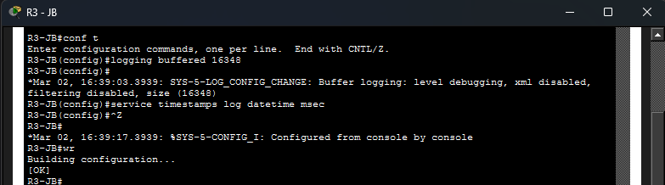
These commands: “logging buffered 16348” and “service timestamps log datetime msec” stores logs into the router’s memory for auditing and precise timestamps for all the log messages. This helps detect suspicious activity and support audits.

11.1.5 SSH Configuration
Secure Shell (SSH) is configured to provide encrypted and authenticated remote access to network devices, in this case it is configured into the routers. By configuring SSH on a router, it ensures that administrative sessions are protected from eavesdropping, credential theft and unauthorized access compared to Telnet. Below are the steps for configuring SSH on a router:
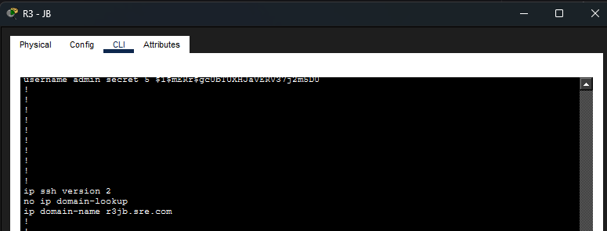
It begins by setting the domain name for the devices using “ip domain-name rxxx.sre.com”. This is required for generating RSA keys for SSH. “ip ssh version 2” forces the router to use SSH version 2 instead of version 1 as it is more secure than version 1.
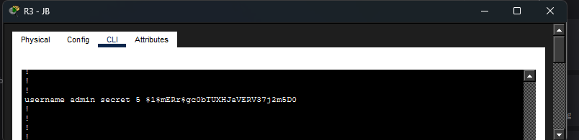
An encrypted local account for SSH login is created with “username admin secret 12345678”. The purpose of using “secret” instead of “password” is because “password” are stored in plaintext whereas “secret” stored in encrypted form.
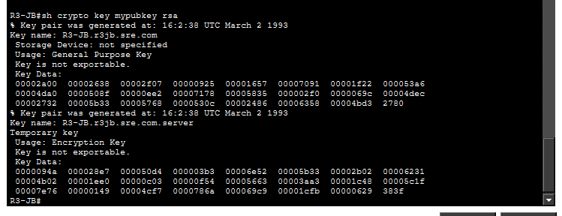
RSA key is required for SSH to work and is generated with “crypto key generate rsa”. 2048 is then entered for the RSA key size in bits.
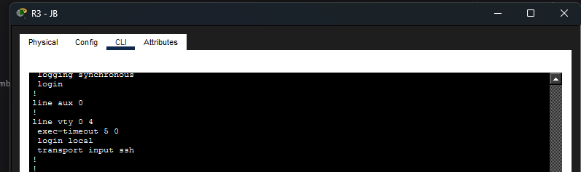
VTY Lines configuration is configured by “line vty 0 4” that configures virtual terminal lines where “0 4” meaning that simultaneous sessions can be up to 5. The idle timeout is set to 5 minutes with “exec-timeout 5 0” to reduce risk if a user forgets to log out. “login local” uses local user database for authentication which is the local user created above. “transport input ssh” allows only SSH connections and disables insecure protocols such as Telnet.
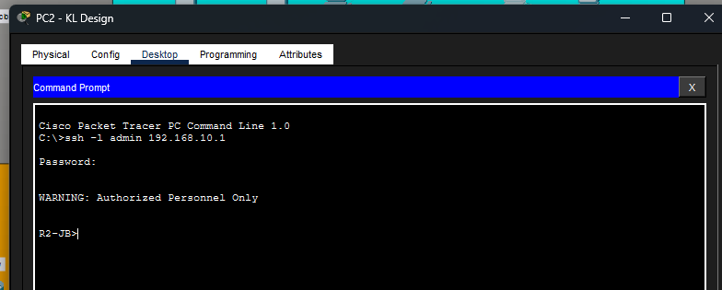
From the command “sh ip ssh”, it is confirmed that the SSH is enabled. Figure above is an example of PC2 From KL Design remoting to the router R2 of JB with the command “ssh -l admin 192.168.10.1”.

11.2 Switches
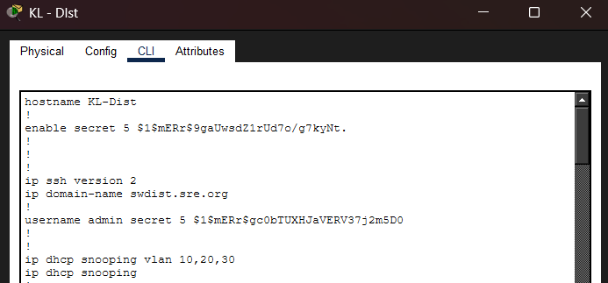
Distribution switch will be set with the hostname KL-Dist to recognize the device in the network. The network uses VLAN 10, VLAN 20 and VLAN 30 to isolate various groups of users or departments into distinct broadcast domains. This gives improved management of traffic and rational segmentation. The switch is also set to support such VLANs with DHCP snooping that is, it can monitor DHCP traffic on VLAN 10, 20, and 30. This is to make sure that the IP address allocation at such VLANs is managed adequately. Moreover, there is the setting of SSH version 2 and a domain name setting that enables remote control of the switch. The local username is generated in order to enable the administrators to log in to manage the device and configure it. In general, the configuration demonstrates that the distribution switch is configured to handle several VLANs, assign IP addresses in those VLANs, and provide an opportunity to perform administrative controls remotely.
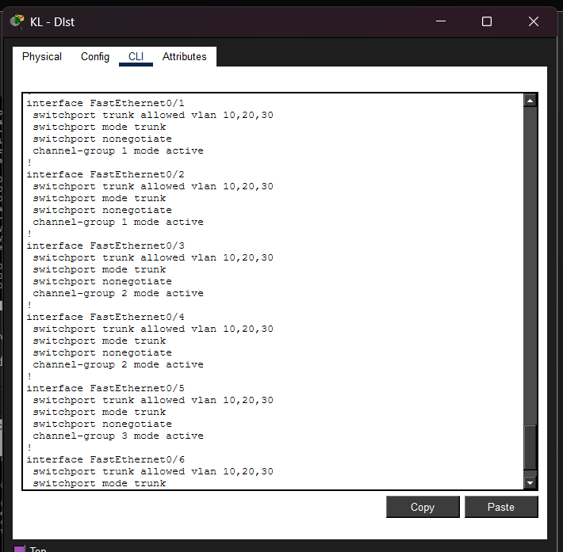
The distribution switch is set to handle the VLAN traffic as well as give redundancy to the network. The FastEthernet interfaces (Fa0/1 to Fa0/6) are configured as trunk ports whereby, VLAN 10, 20, and 30 are able to pass through. switchport nonegotiate Command is used to turn off automatic trunk negotiation to make a trunk more easily configured, more stable, and secure. The switch also has Etherchannel with LACP (mode active) where there are three port-channel with pairs of interface bundling. This modifies bandwidth and offers redundancy whereby in case of failure of one link, the other link will keep on functioning. Comprehensively, the distribution switch concentrates connections of other switches, has multiple VLANs, and enhances the reliability and performance of a network.
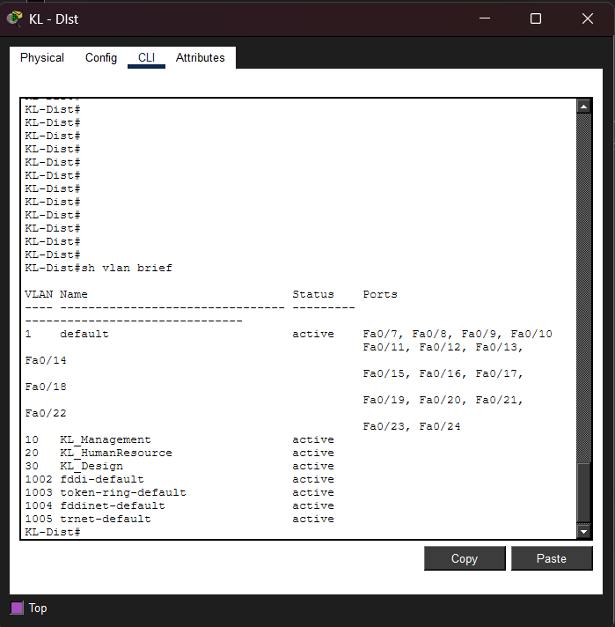
According to the show vlan brief output, the distribution switch is set up to have various VLANs to separate network traffic into various logical groups. The default VLAN is VLAN 1, which has a number of FastEthernet ports (Fa0/7- Fa0/24) allocated to it. It means that these ports are a part of the default network segment. Moreover, three VLANs that are customized are established and switched on in the switch. VLAN 10 is called KL-Management, VLAN 20 is called KL-Human Resource and VLAN 30 is called KL-Design. Such VLANs are utilized in order to logically isolate departments or functions in the organization. Although no access ports are depicted to be assigned to VLAN 10, VLAN 20 and 30 in this output, these VLANs are operational and are probably traversed over trunk links to the other switches. Presence of the default legacy VLANs (1002-1005) exists as well since Cisco switches automatically generate them. In general, the layout indicates that the distribution switch is configured to accommodate various departmental VLANs, which will allow the successful network segmentation and hierarchical traffic management.

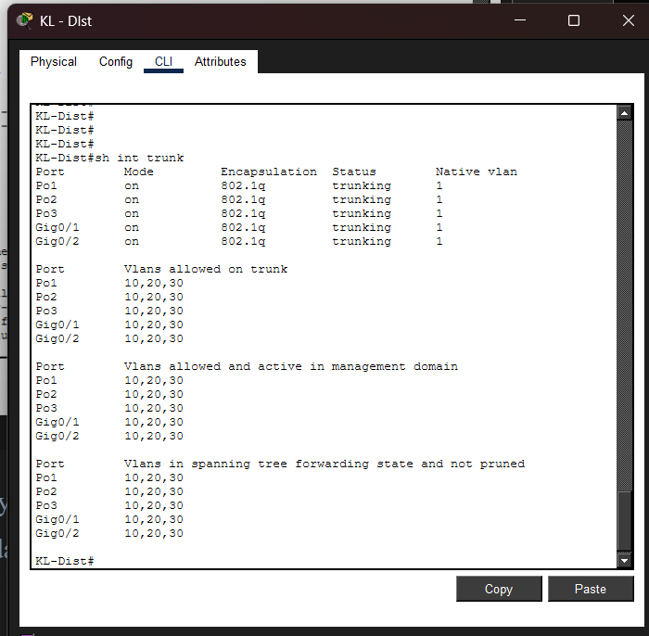
According to the show interface trunk output, the distribution switch is programmed to have various trunk links, through which VLAN traffic can be transmitted over the network. Port-Channel 1 (Po1), Port-Channel 2 (Po2) and Port-Channel 3 (Po3) are in trunk mode with encapsulation 802.1Q. Besides this, Gigafiber Ethernet0/1 and Gigafiber Ethernet0/2 are also set up as trunk ports. Each and every trunk link is in trunking state i.e. it is actively transmitting VLAN traffic. All trunk ports have the native VLAN VLAN 1. All trunk links are permitted VLANs 10, 20 and 30 and these VLANs are also enabled in the management domain. The output also indicates that VLAN 10, 20 and 30 are in the spanning-tree forwarding state and are not pruned which implies that traffic of these VLANs is passing successfully through the trunks. In general, the set-up confirms that the distribution switch is installed correctly and is able to route the VLAN 10, 20 and 30 over aggregated EtherChannel links as well as uplink connections, which is necessary to communicate among the various sections of the network.

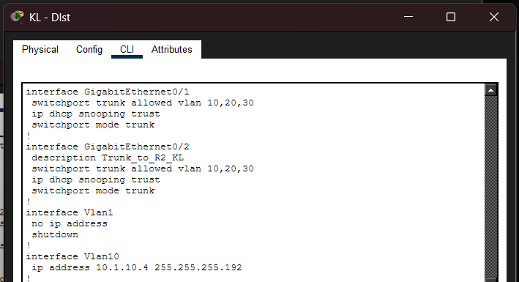
The set up is such that the GigabitEthernet0/1 and GigabitEthernet0/2 are configured as trunk interfaces. Both interfaces permit the passage of VLAN 10, 20 and 30 that is, they are used to communicate traffic of various VLANs between network devices. Gigafibretethernet0/2 is marked by description Trunk to R2 KL meaning that it is connected to a router. Both interfaces are also set as trusted ports in order to snoop DHCP traffic, so legitimate DHCP traffic can be transmitted across them. VLAN1 interface is set to have no IP address and is shut, which is why it is not used to manage and route. The IP address of the Interface VLAN10 is 10.1.10.4 with a subnet mask 255.255.255.192. It means that the distribution switch also has a Layer 3 interface to the VLAN 10 and this interface can provide the inter-VLAN routing as well as be the gateway to the devices within the VLAN. Under this setup, in general, it can be seen that the distribution switch is both operating as a trunk switch and a Layer 3 device routing traffic between VLANs.
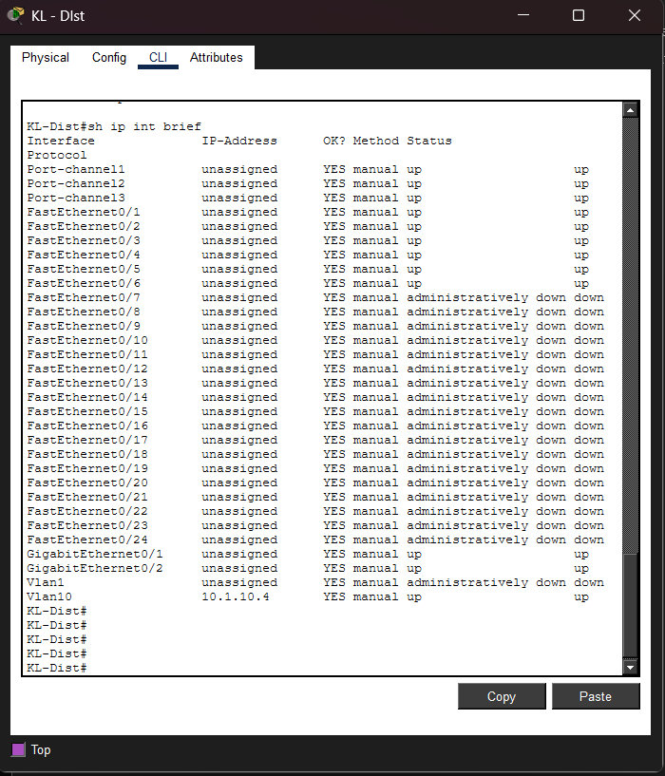
According to the show ip interface brief output, the distribution switch is working as a Layer 2 and a Layer 3 device. All the port-channels (port-channel1, port-channel2 and port-channel3) are up and running thus verifying the EtherChannel groups are formed and up. There are also the physical interfaces FastEthernet0/1- FastEthernet0/6 indicating that the trunk connection to the other switches is functioning correctly. Quite a few other FastEthernet interfaces (Fa0/7 to Fa0/24) are administratively down, i.e. are not currently in use and have been disabled by hand. GigafiteEthernet0/1 and GigafiteEthernet0/2 are online and running indicating that the uplink links are operational. In the Case of Layer 3 configuration, VLAN1 has no ip address and is administratively turned down hence it is not utilized. VLAN10 is IP address 10.1.10.4 and is up, which implies that the distribution switch is serving as the gateway of VLAN 10 and routing inter-VLAN. On balance, the results of the output verify that the trunk links, EtherChannels, and VLAN 10 interface perform well on the distribution switch.

12.1 Security Mechanisms Improvement

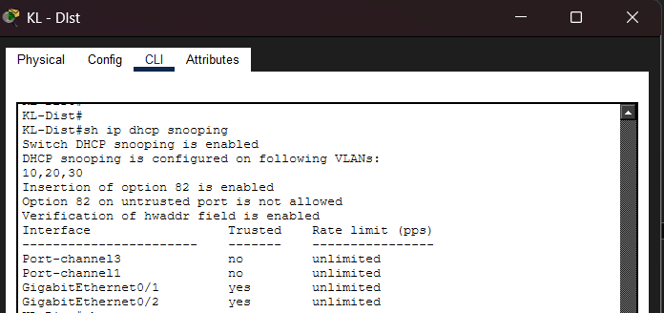
According to the show ip dhcp snooping result, DHCP Snooping is enabled with the distribution switch which manages and monitors the DHCP traffic within the network. DHCP Snooping: this is enabled on the switch worldwide and is configured on VLAN 10, VLAN 20 and VLAN 30. This implies that DHCP messages in these VLANs will be inspected by the switch and unauthorized DHCP responses blocked. Option 82 insertion is activated, and this will enable the switch to include more information in DHCP requests to have a better tracking of the clients. The hardware address field verification is also configured, under which the source MAC address in the DHCP packet should be the same as the MAC address. On the interface list, Port-channel11 and Port-channel13 are identified as untrusted ports, and this indicates that they will reject unapproved replies of the DHCP server. GigabitEthernet0/1 and Gigafibre Ethernet0/2 are set as trusted ports and the legitimate DHCP server traffic is permitted to pass. In general, the results indicate that the DHCP Snooping is correctly set up on the distribution switch in order to manage the DHCP traffic and distinguish between trusted interface and untrusted interface.
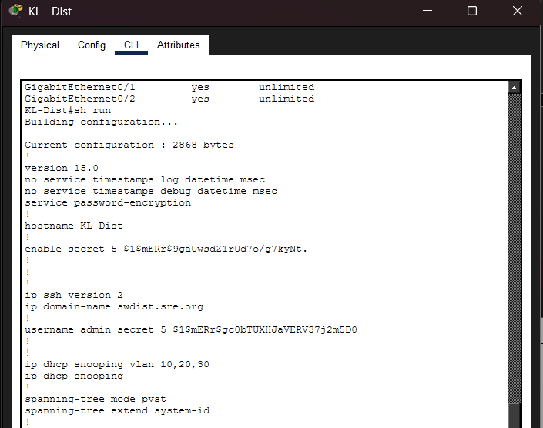

According to the running configuration depicted, the distribution switch is set with a number of significant network configurations. The device is powered by IOS 15.0 and its hostname is KL-Dist in order to identify it in the network. Service password-encryption is used to enable password encryption and an encrypted enable secret has been configured to allow privileged access. SSH 2 has been turned on, and the domain name swdist.sre.org has been configured to have the secure remote management. An administrative user is created under the name administration with an encrypted password. DHCP Snooping is activated on all the link and directly on VLAN 10, 20 and 30. This enables the switch to trace and regulate traffic of DHCP in those VLANs. One adjustment made to Spanning Tree Protocol is the configuration of the spanning-tree performed in PVST mode (Per-VLAN Spanning Tree) this permits each VLAN to possess its own instance of the spanning-tree. Spanning-tree extend system-id command is used to calculate bridge ID effectively to each VLAN. In general, the setup reveals that the distribution switch is configured with the VLAN support, Layer 2 control mechanisms, DHCP monitoring and spanning-tree management in order to make the network functioning stable and ordered.
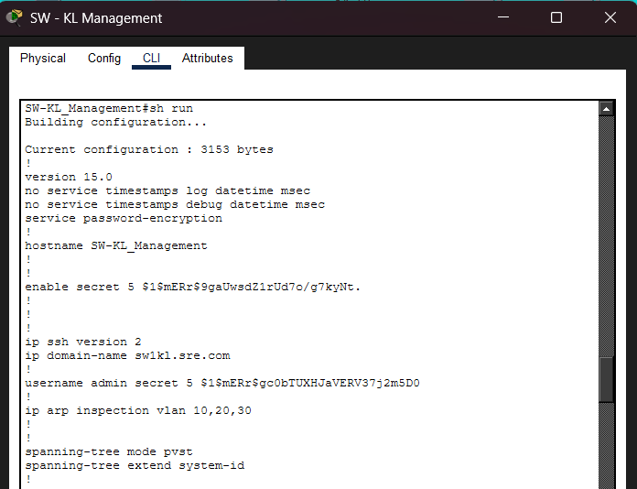
According to the configuration presented above, there are a number of security features applied to the SW-KL-Management switch. Firstly, the password-encryption of services is activated that is, passwords in plain-text are encrypted in the configuration file so that an unauthorized user cannot easily read the passwords. There is the encryption of an enable secret that is used to secure access to privileged EXEC mode. The latter provides the security of only authorized administrators using advanced configuration settings. The version 2 of SSH is activated and a domain name set. It enables the remote operation of the switch in an encrypted communication rather than an insecure protocol such as Telnet. An encrypted password and a username known locally, as the admin are also generated. ip arp inspection vlan 10,20,30 has been used in VLAN 10,20 and 30 as Dynamic ARP Inspection (DAI) is enabled. This security measure prevents ARP spoofing attacks in the network by checking ARP packets in such VLANs. In general, the shift is set with password protection, encrypted remote access, user authentication, and ARP spoofing prevention so that to enhance the Layer 2 security.
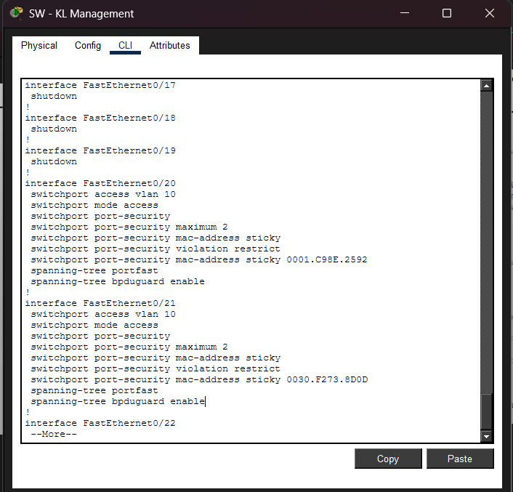
Based on this configuration, numerous Layer 2 security mechanisms have been implemented on access interfaces of the SW-KL_Management switch. The Fa0/18, Fa0/19 and FastEthernet0/17 are all administratively shut. One of the security measures is to disable ports which are not in use to ensure that unauthorized equipment is not connected to the network. FastEthernet0/20 and FastEthernet0/21 will be configured as access ports in VLAN 10. These interfaces are turned on to security of ports to restrict the devices allowed to connect with it. The topology of the MAC addresses is limited to two, which eliminates MAC address floods or attacks. Sticky MAC address is enabled, in this case, the switch would learn and remember the MAC address of the device that is connected to it. Special MAC addresses are also used, which are hand secured. The violation mode will be configured as restrictive, or where unauthorized traffic will be discarded without port being put offline. There is also spanning-tree portfast which is activated to enable the port to quickly move to the forwarding state because it is connected to end devices. spanning-tree bpduguard enable is also set to block a rogue switch automatically by closing the port in case a BPDU is received. In general, the architecture will make Layer 2 more secure because it will disable unused ports, restrict MAC addresses, prevent unauthorized access, and fight the attacks associated with spanning-tree manipulation.
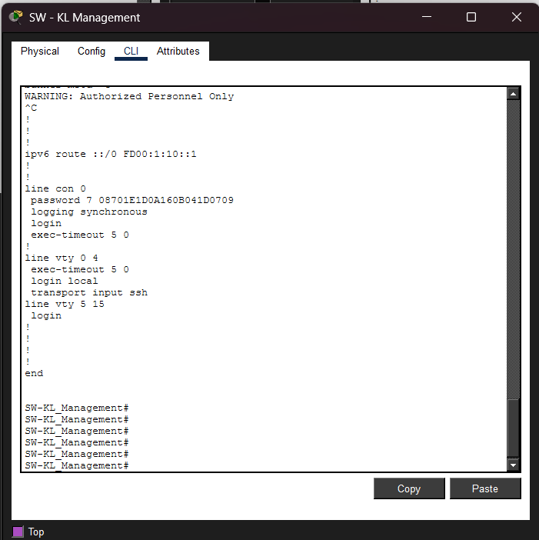
Based on this configuration, numerous Layer 2 security mechanisms have been implemented on access interfaces of the SW-KL_Management switch. The Fa0/18, Fa0/19 and FastEthernet0/17 are all administratively shut. One of the security measures is to disable ports which are not in use to ensure that unauthorized equipment is not connected to the network. FastEthernet0/20 and FastEthernet0/21 will be configured as access ports in VLAN 10. These interfaces are turned on to security of ports to restrict the devices allowed to connect with it. The topology of the MAC addresses is limited to two, which eliminates MAC address floods or attacks. Sticky MAC address is enabled, in this case, the switch would learn and remember the MAC address of the device that is connected to it. Special MAC addresses are also used, which are hand secured. The violation mode will be configured as restrictive, or where unauthorized traffic will be discarded without port being put offline. There is also spanning-tree portfast which is activated to enable the port to quickly move to the forwarding state because it is connected to end devices. spanning-tree bpduguard enable is also set to block a rogue switch automatically by closing the port in case a BPDU is received. In general, the architecture will make Layer 2 more secure because it will disable unused ports, restrict MAC addresses, prevent unauthorized access, and fight the attacks associated with spanning-tree manipulation.
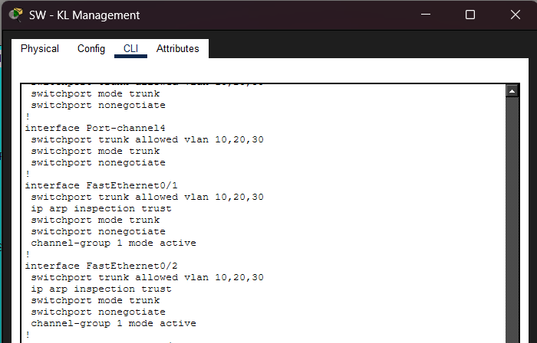
In this setup, security settings are used on trunk and Etherchannel interfaces on the SW-KL Management switch. The trunk interfaces and Port-channel4 is set with switchport mode trunk so that VLAN 10, 20, and 30 can be passed over it. The switchport nonegotiate command is turned on and this turns off the Dynamic Trunking Protocol (DTP). This helps to prevent automatic trunk negotiation and help to guard against vlan hopping attacks. FastEthernet0/1 and FastEthernet0/2 are set as trunk ports and joined together with channel-group 1 mode active which creates an EtherChannel through LACP. This will offer redundancy as well as bandwidth multiplicity and methods of handling multiple links as one logical connection. The ic arp inspection trust command is configured on these trunk interfaces. This identifies them as trusted ports to Dynamic ARP Inspection (DAI) so that valid ARP packets of trusted devices may go by. ARP packets would be checked and blocked at untrusted ports to eliminate ARP spoofing attacks. In general, this is a more robust Layer 2 security system due to the disabling of DTP and elimination of VLAN hopping, support of ARP inspection, and protection of the trunk through Etherchannel connections.

12.2 Recommendations
Three (3) More Security Improvement Recommendations.
1. Implement Virtual Private Network (VPN)
The organization can deploy a VPN solution to secure remote access to the internal network. A VPN encrypts data transmitted between remote users and the organization’s network, preventing attackers from intercepting sensitive information. This is especially important for employees working remotely. By using secure VPN protocols, the organization can ensure confidentiality and integrity of data communication.

2. Deploy Security Information and Event Management (SIEM)
A SIEM system collects and analyses logs from network devices, servers, and security systems in real time. It helps detect unusual activities, potential intrusions, or policy violations. By centralizing log monitoring and generating alerts, the organization can quickly respond to security incidents and reduce the impact of attacks. This improves visibility and overall security management.

3. Implement an Intrusion Detection/ Prevention System (IDS/IPS).
This can be achieved by installing an IDS/IPS that can be used to check network traffic in the event of suspicious or malicious activities. An Intrusion Detection System (IDS) warns off administrators of unusual activity being used, and an Intrusion Prevention System (IPS) can prevent or even halt the attack on its own. This gives a live view and enhances the overall protection in the network.

13.0 IOT
VLAN 90 is created to logically separate IoT devices from other departments. VLAN segmentation improves network security and reduces broadcast traffic by isolating IoT traffic within its own network.
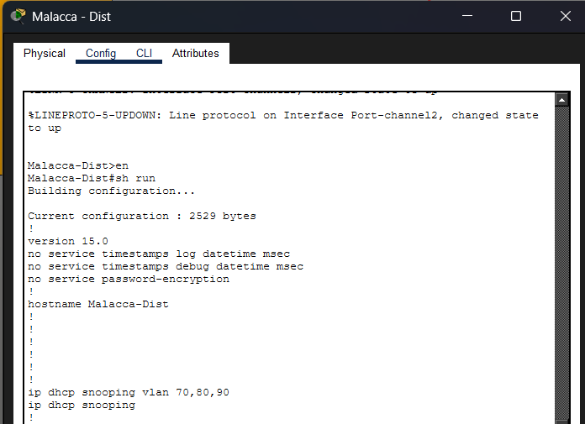
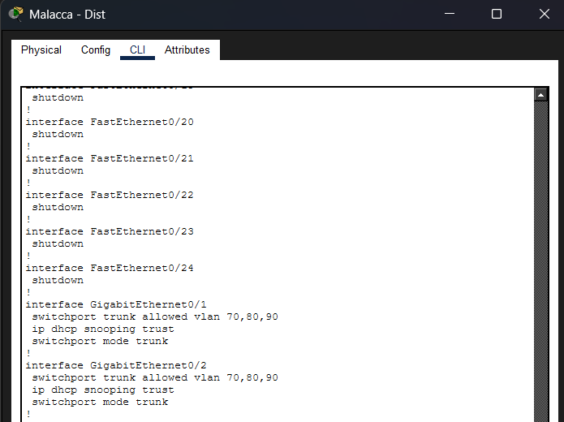
IP DHCP Snooping is implemented on the Malacca distribution switch specifically to protect the IoT VLAN (VLAN 90) from rogue DHCP server attacks. By enabling DHCP Snooping for the IoT network, the switch ensures that only DHCP responses received from trusted trunk interfaces are allowed, while any unauthorized DHCP server messages from access ports are blocked.
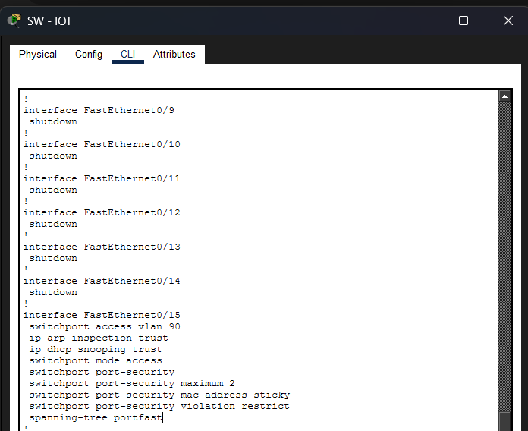
FastEthernet0/15 is configured as a secure access port connecting the IoT Gateway to VLAN 90 (IoT network). The port is set to access mode to ensure it carries traffic only for the designated VLAN, providing proper network segmentation. Port security is enabled with a maximum of two MAC addresses and sticky learning, allowing the switch to automatically learn and bind connected device MAC addresses to prevent unauthorized access. The violation mode is set to restrict, which blocks traffic from unknown MAC addresses while keeping the port active and logging the incident. Additionally, spanning-tree portfast is enabled to allow the port to transition quickly to the forwarding state, ensuring faster device connectivity while maintaining network stability and security.

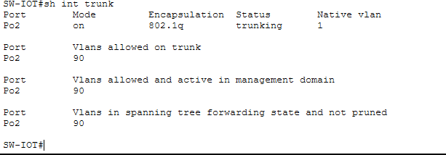
The trunk port between the switch and router is configured to allow multiple VLANs (70, 80, 90). This enables inter-VLAN communication using Router-on-a-Stick.
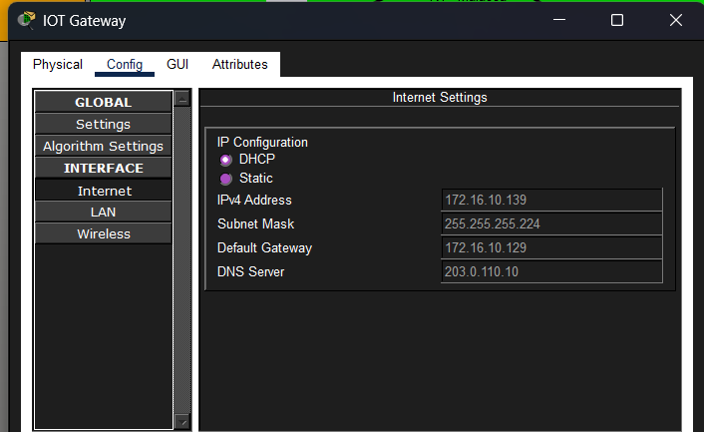
A DHCP pool is configured to automatically assign IP addresses to devices in VLAN 90. The router uses the ip helper-address command to forward DHCP requests to the centralized DHCP server. So the IoT Gateway Internet interface is set to DHCP so it can obtain an IP address (172.16.10.139) from VLAN 90. This connects the IoT Gateway to the enterprise network.
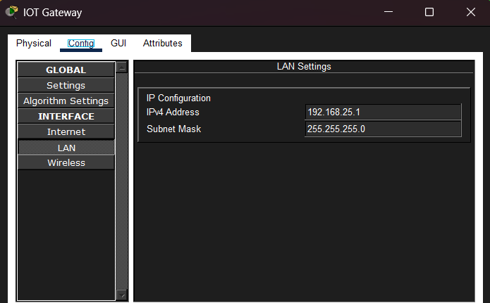
The LAN interface is configured as 192.168.25.1/24. This creates a private internal network where IoT devices such as Door, WebCam and FAn will connect.
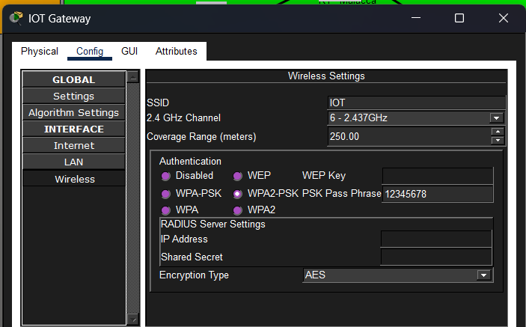
The SSID and WPA2 PSKsecurity are configured on the IoT Gateway. This allows IoT devices to connect securely via wireless connection.

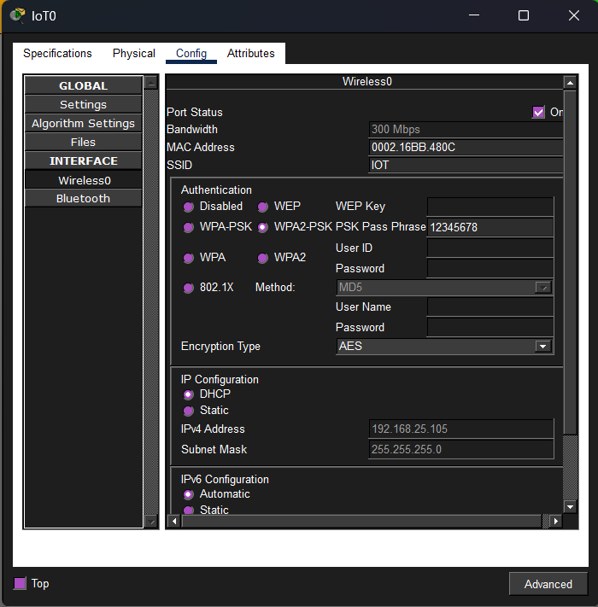
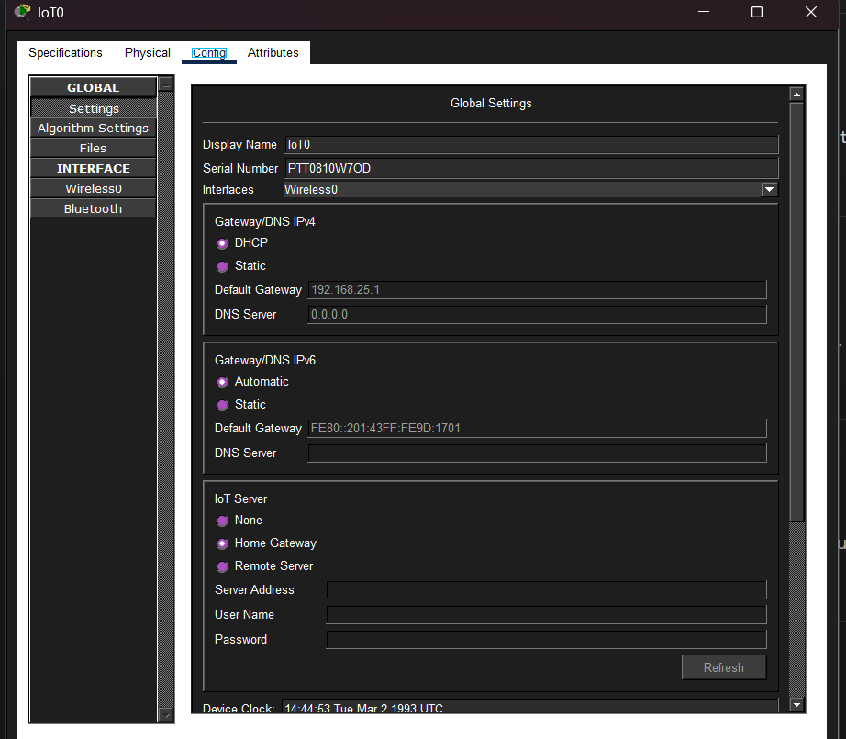
The SSID and WPA2 PSK security are configured on the IoT device also such as Door and go through the setting select the HomeGateway.
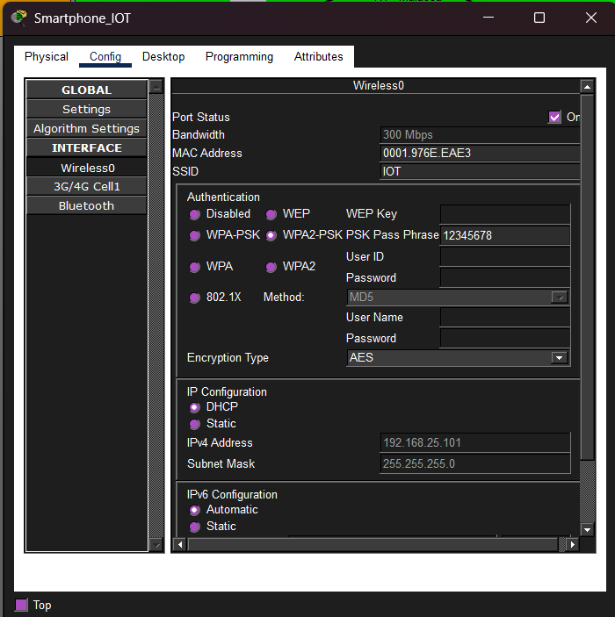
Config the smartphone with SSID and WPA2 PSK security same with IOT-Gateway, after that accessing to the Desktop > IOT monitor to control the IOT Devices.
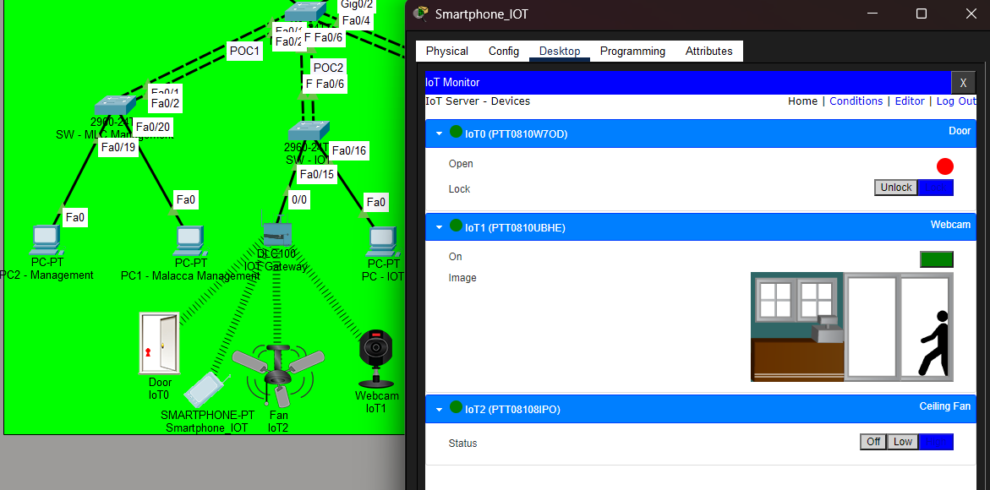
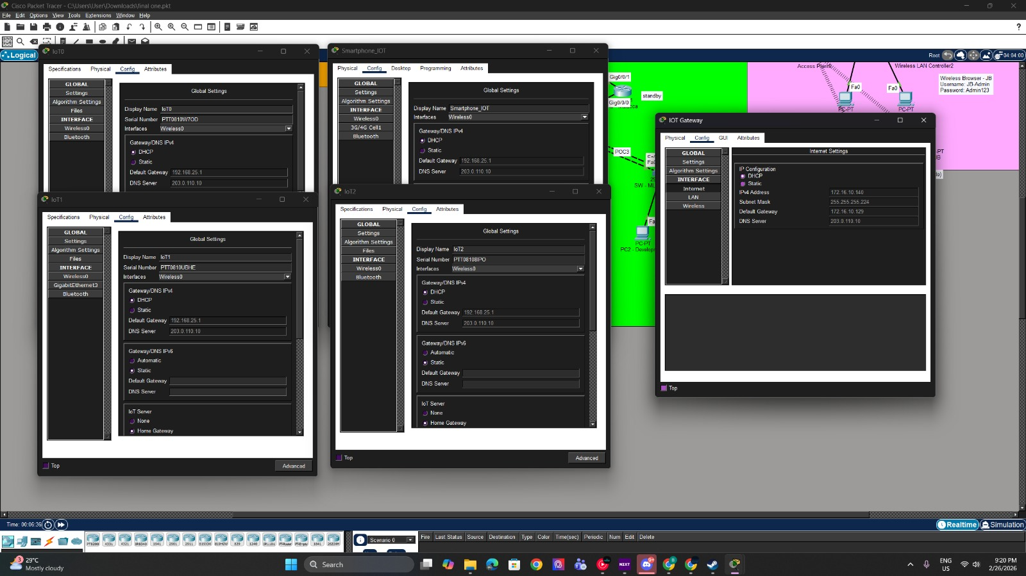
Reference for all IoT wireless devices can get DHCP.

14.0 Conclusion
In conclusion, this project was able to design and implement a secure, scalable and fully interconnected multi-site enterprise network to Suzlon. The network takes a hybrid hierarchical star topology with a hub and spoke WAN architecture with KL as the central hub linking the Penang, JB and Malacca. Using good VLAN segmentation, Router-on-a-Stick application, and OSPF dynamic routing of IPv4 and IPv6, the complete inter-site communication was realized and tested using ping and traceroute.
DHCPv4 and DHCPv6 allowed automation of the IP addresses assignment on many LAN segments, which enhanced the efficiency and minimized the number of manual configuration errors. The implementation of wireless LAN architecture in Penang and JB branches was done successfully with the use of WLC configuration with WPA2 security to ensure centralized wireless management and security to the clients. Furthermore, network availability, bandwidth use and fault tolerance were improved by the redundancy technology like HSRP and EtherChannel.
Mechanisms in Layer 2 security like the DHCP Snooping, Dynamic ARP Inspection (DAI), Port Security, BPDU guard, and trunk hardening were applied to prevent or reduce the typical attacks on the LAN like DHCP spoofing, ARP spoofing, MAC flooding and VLAN hopping. The administrative protection was further enhanced by basic router and switch configurations and SSH remote management. The centralization of server services such as DNS, FTP, Web and DHCP into Server Farm guaranteed the availability of internal service delivery to all branches. In addition, the IoT implementation of the Malacca branch exhibited a secure network segmentation system and a controlled wireless connection to smart devices.
In general, the project requirements are satisfied with the proposed network design as it offers organized topology design, efficient IP addressing with the help of VLSM, dynamic routing, redundancy mechanisms, wireless deployment, and full Layer 2 security implementation. The outcome of the simulation simulation using Cisco Packet Tracer shows that the network is functioning and functioning well and in a secure manner to provide a strong enterprise network solution to Suzlon.

15.0 References
- Configuring Secure Shell. (n.d.). Retrieved February 26, 2026, from https://www.cisco.com/c/en/us/td/docs/ios-xml/ios/sec_usr_ssh/configuration/15-mt/sec-usr-ssh-15-mt-book/sec-usr-ssh-sec-shell.pdf
- Basic Router Configuration [Support]. (n.d.). Cisco. https://www.cisco.com/en/US/docs/routers/access/800/850/software/configuration/guide/routconf.html
- ‌IP Routing: OSPF Configuration Guide, Cisco IOS Release 15S - Index [Cisco IOS 15.4S]. (2018, July). Cisco. https://www.cisco.com/c/en/us/td/docs/ios-xml/ios/iproute_ospf/configuration/15-s/iro-15-s-book/iro-15-s-book_index.html
- ‌Articles | Cisco Press. (n.d.). Www.ciscopress.com. https://www.ciscopress.com/articles/article.asp
- IEEE. (2018). IEEE standard for information technology—Telecommunications and information exchange between systems—Wireless LAN (IEEE 802.11). IEEE Standards Association.
- PacketTracerNetwork. (n.d.). Packet Tracer 7.3 - WLC configuration. Packet Tracer Network. https://www.packettracernetwork.com/tutorials/pt71-wlc-configuration.html
- Configure Port to VLAN Interface Settings on a Switch through CLI, 13-Dec-2018, from https://www.cisco.com/c/en/us/support/docs/smb/switches/cisco-small-business-300-series-managed-switches/smb5653-configure-port-to-vlan-interface-settings-on-a-switch-throug.html
- Configuring VLANs – Cisco
https://www.cisco.com/c/en/us/td/docs/switches/datacenter/nexus5000/sw/layer2/421_n1_1/b_Cisco_n5k_layer2_config_gd_rel_421_n1_1/Cisco_n5k_layer2_config_gd_rel_421_n1_1_chapter4.pdf
- Alexander. (2024, Jan 22). How to Configure a Web Server in Packet Tracer | How to Configure HTTP Server in Packet Tracer. Retrieved from netizzan: https://netizzan.com/how-to-configure-a-web-server-in-packet-tracer/

- Kimanzi, S. (2018, July 5). DNS server configuration in Packet Trace. Retrieved from Computer Networking Tips: https://computernetworking747640215.wordpress.com/2018/07/05/dns-server-configuration-in-packet-tracer/

- Panchal, S. (2023, March 19). FTP server configuration in cisco packet tracer. Retrieved from Medium: https://medium.com/@20ce070/ftp-server-configuration-in-cisco-packet-tracer-73dae365e078

- Ramadhani, D. (2025, Aug 20). Cisco Packet Tracer Tutorial: DHCP Server Configuration Explained. Retrieved from dev: https://dev.to/dimasqiramadhani/cisco-packet-tracer-tutorial-dhcp-server-configuration-explained-160c

- Packet Tracer – Adding IoT Devices
https://contenthub.netacad.com/legacy/I2PT/1.1/en/course/files/5.1.1.2%20Packet%20Tracer%20-%20Adding%20IoT%20devices%20to%20Smart_Homes.pdf

16.0 Workload Matrix
Area | Kelver Foo Qai Wen  TP075681 | Lian Yuan Shen  TP075827 | Heng Li Yang  TP070036 | Chong Lih Sin TP068438 | Justin Chew Chun Yuen  TP076179 | Chew Wen Kang  TP069443
Introduction |  | ✔ |  |  |  | ✔
Network Layout |  | ✔
IPv4 and IPv6 Addressing Table |  | ✔ |  | ✔ | ✔
WAN and LAN configuration |  |  |  | ✔ | ✔
WLAN Architecture |  |  |  |  |  | ✔
Etherchannel | ✔
HSRP Implementation | ✔
Server Services |  |  | ✔
Tracert/Ping Commands |  |  | ✔
Security Mechanisms Improvement |  |  |  | ✔
IOT |  | ✔
Conclusion |  | ✔ |  |  |  | ✔

